**SAP HANA XSA**

**HANA Cockpit Admin 🡪 Use to connect the HANA System with XSA Server, The XSA_ADMIN access need to Hana cockpit access**

**In the XSA, We have Organization and spaces defined inside of the ORG. The spaces like the DEV, QA and PROD**

DEV SPACE

QA SPACE

ORGANIZATION

PROD SPACE

* In XSA, We will have the Organization maintained and Each Organization will have the **SPACES** defined inside the organization.
* Each **SPACE** will have the single Tenant or the multiple Tenants also.
* We can see the organizations and spaces inside the hana cockpit.

**ORGANIZATION**

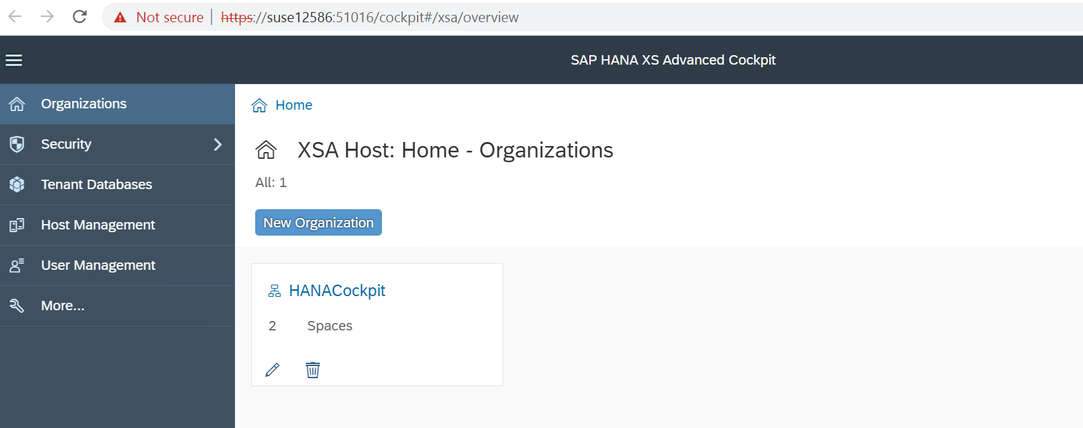

**SPACES Defined Inside Organization**

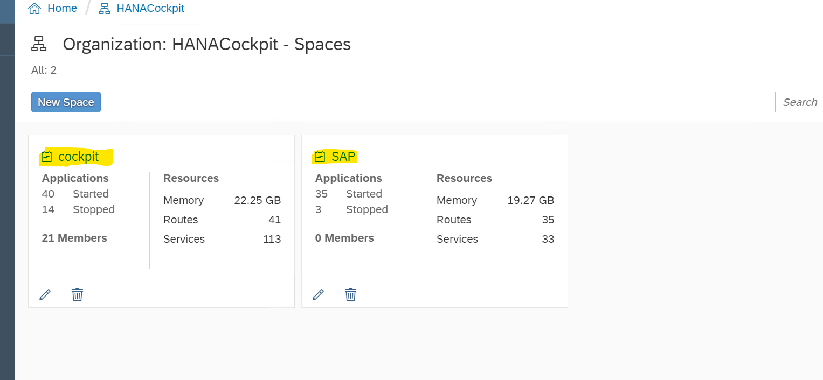

**Creating the USER In HANA XSA**

* If you wish to create the new user in SAP HANA XSA, you should have access to the admin user (XSA_ADMIN)

**SECURITY--🡪USER Management🡪New User**

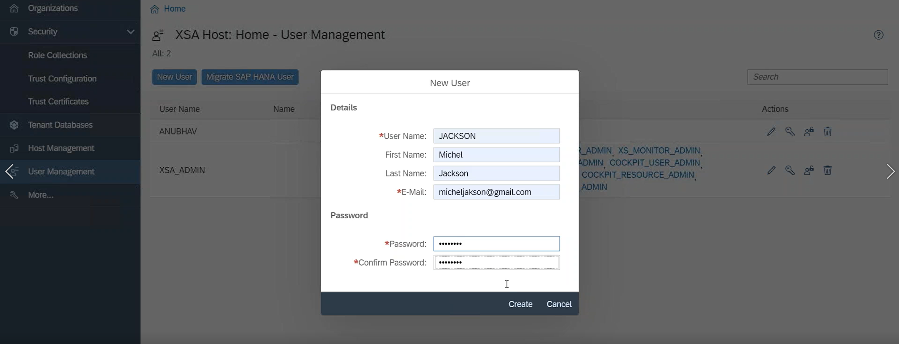

* **Once we created the User, The Web ide tool access is only for developer. The Authorization is controlled Roles.**
* **A Role is a Permission which is granted to the user,**

**The user can’t be able to access the Web Ide until unless he has the WEBIDE_DEVELOPER Role for the User.**

**If the user is missing the WEBIDE_DEVELOPER Role, The Web Ide will not load and it will show like the below**



***Create the New Role Collection and assign the Role to the User***

**Security**

**Create Role**

**Create Role**

**Role Collection**

WEBIDE Developer-Denied Deployment

WEBIDE Developer

WEBIDE Administrator

**We can create the Role Collection by selecting the appropriate Roles based on the user roles assigned to .. The Created Role collection can be assigned to user.**

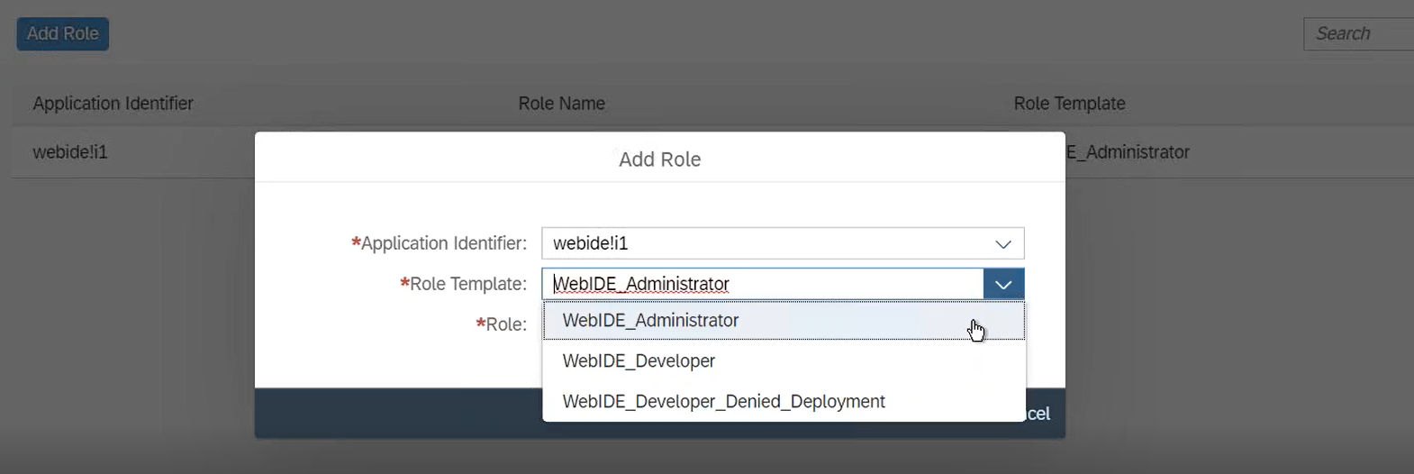

**Each Module in the MTA Project will on independently and runs on the Micro Services, meaning the Each Module will run on different micro services.**

***MTA PROJECT* (Multi Target Application Programming Model)**

MTA PROJECT (Multi Target Application Project)

DB MODULE

APPLICATION MODULE

Web Module

* In XSA, We have MTA Project(Multi Targer Application Programming Model) Project which provides the ability to integrate the **DB(SRC) , NODE OR XSJS(SRV) and WEB Model to** integrate the Data base, application programming and UI design in one place

Steps to create the MTA PROJECT

**Right click on Workspace-🡪 Click on MTA PROJECT-🡪 Project Name -🡪 SELECT SPACE-🡪 Finish**

* Once the MTA PROJECT, Now we can create the DB module.

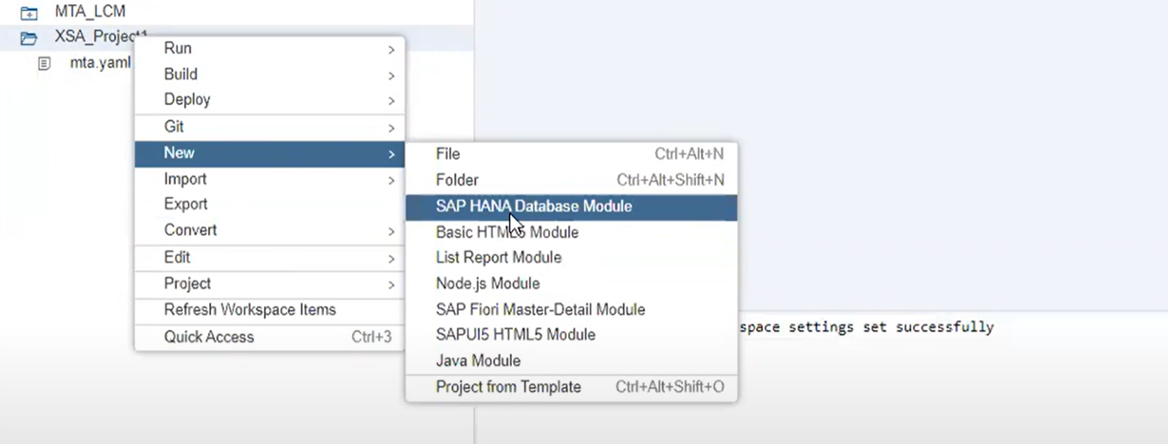

* Once we create the DB Module by default the DB module contains **the Package.json Configuartion files and the SRC folder with the .hdbconfig and .hddnamespace files contained in it.**

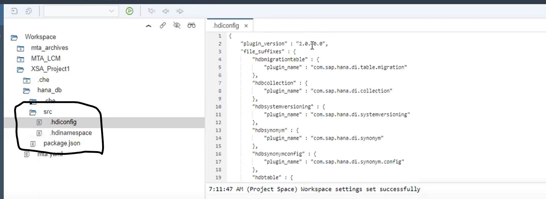

***hdbConfig File :-* The HDB config file contains the Plug Ins for generating the run time objects in for the design time objects in the container. The hdbconfig file is wizard generated file and you shouldn’t mess up any settings. Always Your Hana Version should be in sync with the hdbconfig file plugin version.**

**Each Plugin has the capable of processing the each type of file (hdbview, hdbsynoym).**

***DB corresponding Package.json***

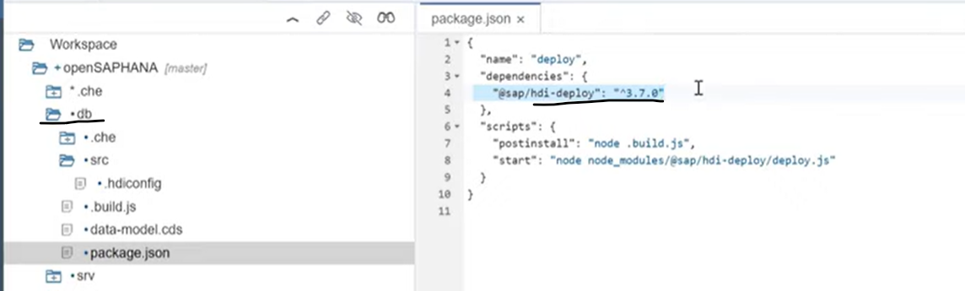

**Package.json**

* **It’s a project descriptor file, it’s existed in the Root directory of the Project**
* **It Contains the Project details like name,Version, decription, licensce, author and Company**
* **It contains all the dependencies( All Module)**

**To Create package.json file we just go to the root directory of the project and type command npm int**

**The Package.json is node js module it’s essential tells the what version the deployer will be used to deploy the objects to container**

**@sap/hdi-deploy: ^3.7.0**

**The Deployer will deploys the data base objects to run time objects inside the container and the deployer is part of the SAP NPM module public repository you can made update.**

Once we create the DB Module, The DB module propertied can be automatically in the MTA YMAL file

**General Theory🡪 In XS Classic the database tables will get created inside the specified schemas. But there will be a chance that two developers might have to work on common table**

**Possibility 1🡪 Developr1 would have been deleted the data which might require the data for Developer 2**

**Possibility 2🡪 Developr2 would have been added the data which might require the mess for the Developer 2**

Consider the above Two Developers disclaimers, it’s better to have the data Isolation which will not cause the issue for the two developers when they work on the common Objects.

The SAP has come up with the Containers in XSA which will isolated which other and working with their own set of the data inside their containers.

***CONTAINER*🡪 Containers are Isolated each other and mange separately.**

**PROJECT 2**

**PROJECT 1**

**PROJECT ONE**

**PROJECT TWO**

DB1 Container

DB2 Container

DB1 Container

DB2 Container

S/4 HANA

* For Each DB module inside the Project as separate container will get generated and Isolated with each Other.
* The Container in XSA will also called as the SCHEMA (In XSC we would maintain the data inside the schema tables and But in the XSA will have DB explorer which containers holds the DB objects).
* The Project will have different Projects like SALES will have one project with DB module and INVENTORY Project will have the DB Module

For Every Container (Schema) There will be 2 users which are created automatically

**Schema Owner** 🡪 Owns the object Permission to destroy and recreate new objects

**Application User**🡪 Permission to Read/ Write/ Delete data inside the container

**MTA.YAML FILE**

**MAT.YML file is the heart and soul of the project, It keep tracks of all the modules and all the Resources in project and it’s mainly allows to define the relationships between the objects dependances**

**The YMAL will have the Module and Resources**

**MODULE🡪** The Module has the DB we create with **Name: DB**

**The Type is the HANA Dat0aBase🡪 Type:hdb(Hana DB )**

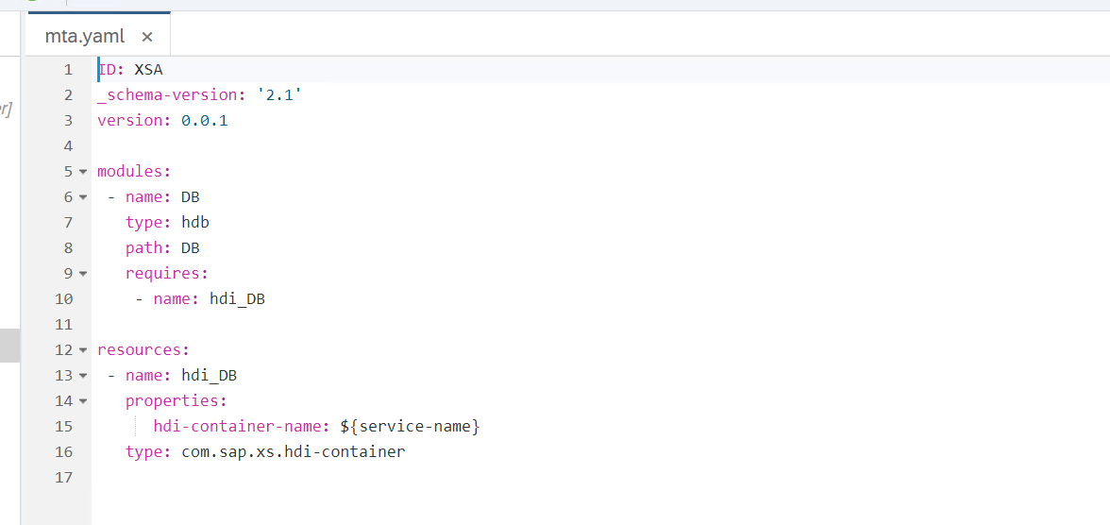

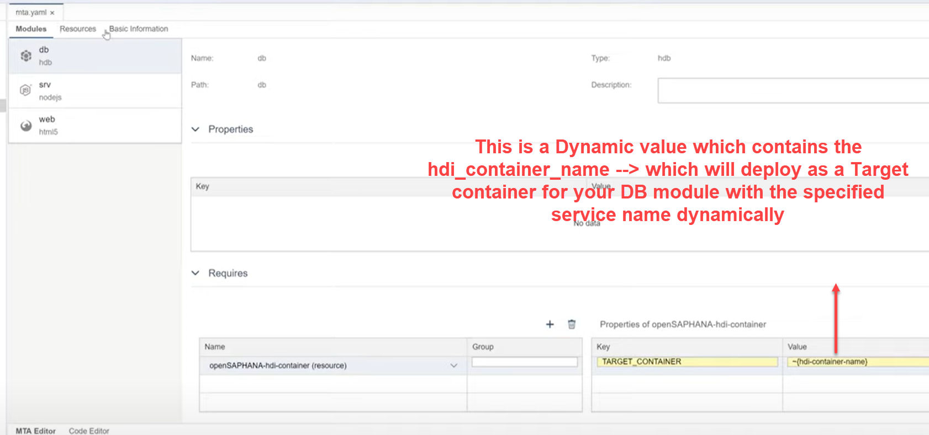

Here the Container names will get generated dynamically by wizard itself, there is no need to hard code anything.

**Here the Each User will have their own set of the data and own technical users and own container and own schema to work with the data. Each developer can work on independently and parallel each of them without messing up the data and objects.**

**Each container is isolated each other but it will single hana instance and single hana mdc client**

**RESOURCES🡪 The resources mainly act as a Service which is needed for the existing the design time objects as data base objects in the container**

A resource for HDI container is created and it is assigned to DB module as required object. Resource is a service with HDI-shared plan which will be used to hold the DB artifacts. DB module is an application which requires the HDI container service.

**Note🡪If you’re not specifying the schema name while DB module inside the MTA Project the system by default will create the schema name with specific format like PROJECT_NAME_DB_MODULENAME**

**If you need create table and existing data base object/ any objects you need to create you need the service, In XSA resource will act as a Service.**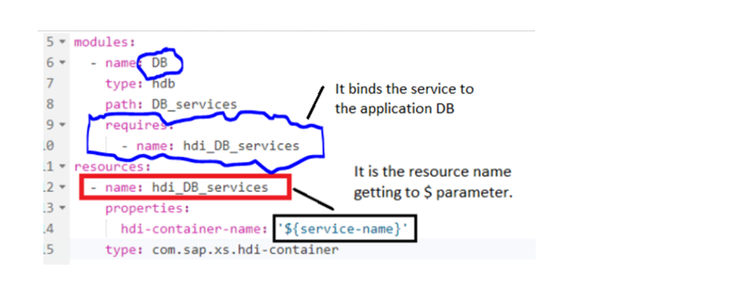

**Here The Service name is Binds Parameter and Parameter getting values points in the Module section to Build Object**

***If you don’t have the service, you will have the container and if don’t have container you will not have data base Objects* 🡪**

Service

DB Objects

Container

*Properties of a resource:* properties are useful to expose the resource in other parts of MTA

application, you can have dynamic parameter to hold the resource name. In this example it is

**${service-name}.** so the service name goes into it.

Inside the Module section of the **REQUIRES, we need the resource (service name) from the resource** to build the design time objects to store as run time object inside the container.

Here Inside the Resource section if you see resource name is bind with the dynamic parameter and the resource name is **hdi_DB-🡪 This hdi_DB resource or service would need in the Module section of the Requires to Build.**

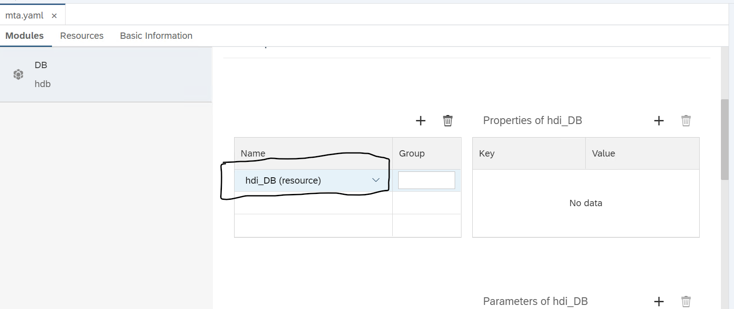

**di builder-🡪 The di-builder is the standard application running on the dev instance or Dev space and will binds to your service**

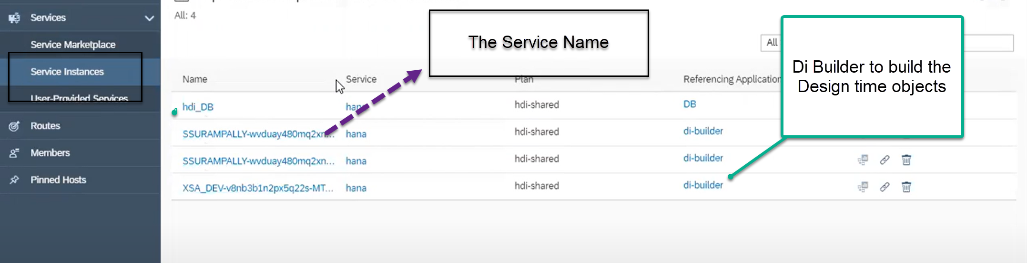

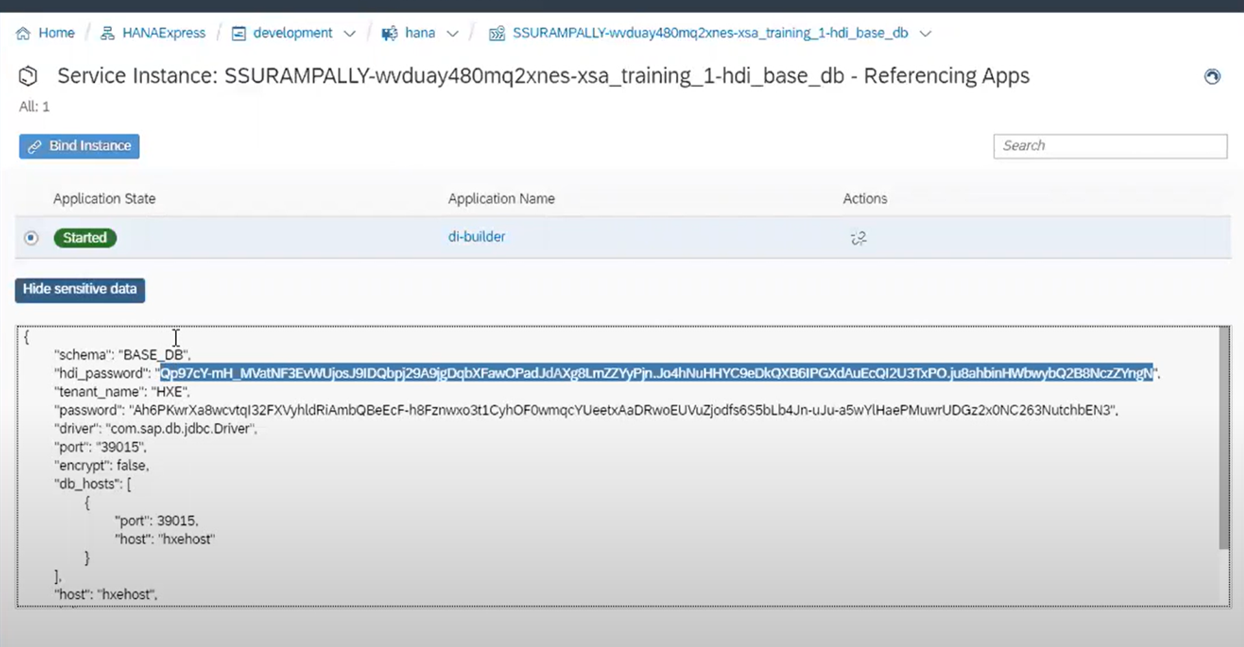

Once we go inside the DI-Builder, we could see that the password and DB name of the DB container.

**Design Time Objects in XSA-🡪**

**CREATING TABLE in SAP HANA XSA with the syntax**

column table employee(id int, name VARCHAR(100),Age tinyint) ;

insert into employee values (101, 'Chris', 20);

insert into employee values (102, 'William',30);

COLUMN TABLE "BusinessPartner"("PARTNERID" NVARCHAR(10) NOT NULL,

"PHONENUMBER" NVARCHAR(15),"ADDRESSID" NVARCHAR(10),"COMPANYNAME" NVARCHAR(100),

PRIMARY KEY (

"PARTNERID")

[**https://blogs.sap.com/2019/09/08/apps-and-services-of-db-module-in-xsa-mta-project-detailed/**](https://blogs.sap.com/2019/09/08/apps-and-services-of-db-module-in-xsa-mta-project-detailed/)

**HANA Tiny World Application -🡪**

**https://blogs.sap.com/2016/03/28/developing-with-xs-advanced-a-tinyworld-tutorial/**

***DB OBJECTS***

    type BusinessKey : String(10);

    type SDate : DateTime;

    type CurrencyT : String(5);

    type AmountT : Decimal(15, 2);

    type QuantityT : Decimal(13, 3);

    type UnitT : String(3);

    type StatusT : String(1);

       type HistoryT {

        CREATEDBY : BusinessKey;

        CREATEDAT : SDate;

        CHANGEDBY : BusinessKey;

        CHANGEDAT : SDate;

    };

    entity Headers {

        key PURCHASEORDERID : Integer;

            ITEMS          : association to many Items on ITEMS.POHeader = $self;

            HISTORY        : HistoryT;

            NOTEID         : BusinessKey null;

            PARTNER        : BusinessKey;

            CURRENCY       : CurrencyT;

            GROSSAMOUNT    : AmountT;

            NETAMOUNT      : AmountT;

            TAXAMOUNT      : AmountT;

            LIFECYCLESTATUS : StatusT;

            APPROVALSTATUS  : StatusT;

            CONFIRMSTATUS   : StatusT;

            ORDERINGSTATUS  : StatusT;

            INVOICINGSTATUS : StatusT;

    }

    entity Items {

        key POHeader     : association to Headers;

        key PRODUCT      : BusinessKey;

            NOTEID       : BusinessKey null;

            CURRENCY     : CurrencyT;

            GROSSAMOUNT  : AmountT;

            NETAMOUNT    : AmountT;

            TAXAMOUNT    : AmountT;

            QUANTITY     : QuantityT;

            QUANTITYUNIT : UnitT;

            DELIVERYDATE : SDate;

    }

***Git Repository –* It’s a distributed repository system for Source Code Management**

ACCESS SECENARIOS-🡪

[**https://developers.sap.com/tutorials/haas-dm-access-cross-container-schema.html**](https://developers.sap.com/tutorials/haas-dm-access-cross-container-schema.html)

[**https://blogs.sap.com/2019/10/02/mta-apps-and-services-part-2-schema-access-services-and-service_replacements/**](https://blogs.sap.com/2019/10/02/mta-apps-and-services-part-2-schema-access-services-and-service_replacements/)

***SCENARIO 1***

***Accessing the Classical Schema Object in SAP HANA XSA***

1.Accessing Classical schema DB objects in SAP HANA XSA: -

**In classic, The SYS_REPO is owning the database objects and all the runtime generated reporting views (Calculation views) stored inside the SYS_BIC schema and the run time hana views owned by SYS_BIC schema.**

**In XSA advance all the data base objects (creating and activating the objects) will be hold the container user.**

To access the Classical DB Tables into your inside your Project DB module we should have create the Synonym to access the tables.

Before we create the Synonyms to access the classical tables, The Synonym will act as a Remote Pointer for the tables.

**we should have connection established between the XSA classic and XSA Advance. To enable the connection, we have to have the CUSTOME USER PROVIDER SERVICE (essential this will act as a Connection)**

**Here the CUPS is a service which enables the bridge connection from SAP HANA classical to XSA.**

**Note -The Technical User of the XSA will only have the access to Container objects and he can’t have be the ability to access the Foreign schema or classic schema objects and we don’t have grants file to assign to the technical user to access the data**

**The Below pictures illustrating the flow of steps involved in accessing classic DB objects into SAP HANA XSA**

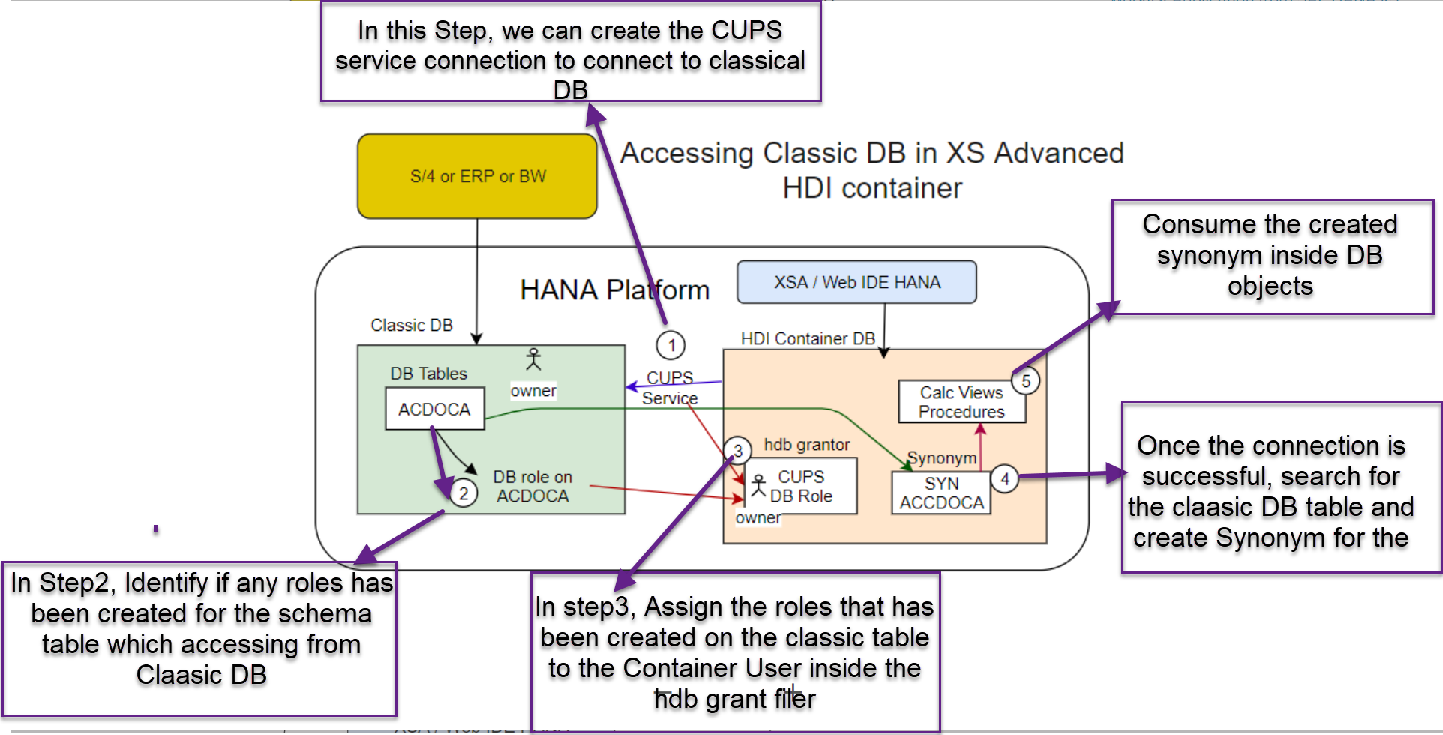

**1).** Create the Database connection (Nothing but the service) **by right clicking on the DB folder and select New and click on SAP HANA Service Connection in XSA web Id**.

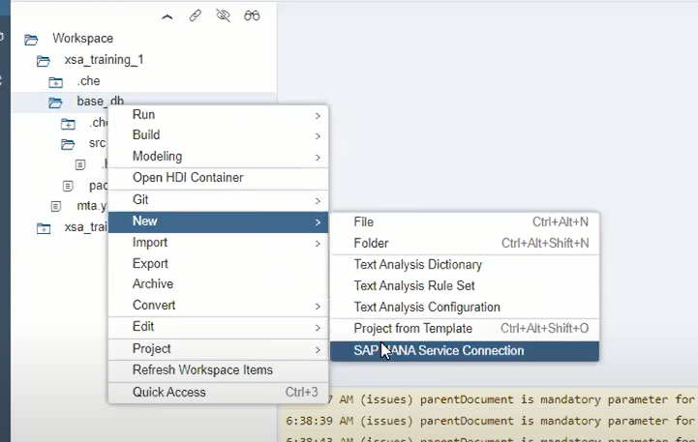

**2).** As we are accessing the classical DB, so it will be the Non HDI container. Select the Non HDI container

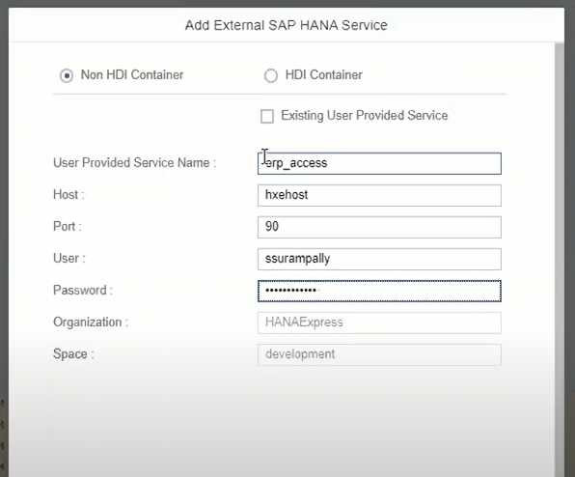

ORGANIZATION

**3)**. Once we created the User Provided USER PROVIDER SERVICE, We can see the created Service under the User-Provider Services section in the Clod Cockpit or HANA Cloud Platform.

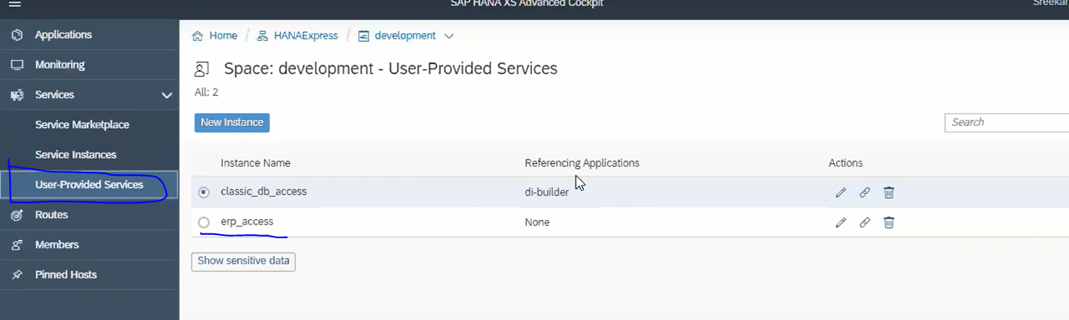

**4).** Under the Resource section click on add Resource and Provide the necessary details to communicate the Resource and Module section.

* In order to access the Service name which you have created for connecting the classic DB outside of the resource module section, we bind the service name as dynamically by passing it with the **${Service_Name}**.

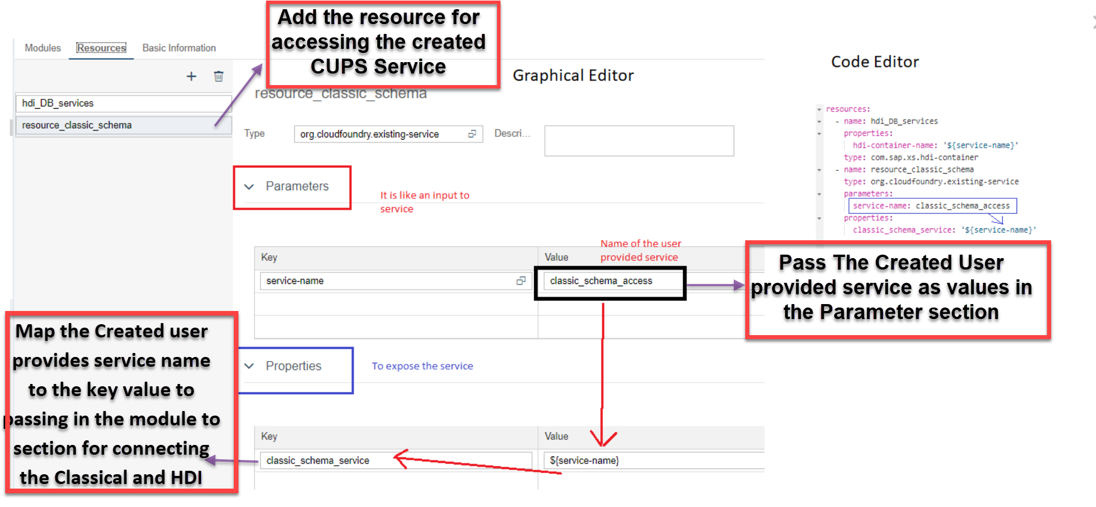

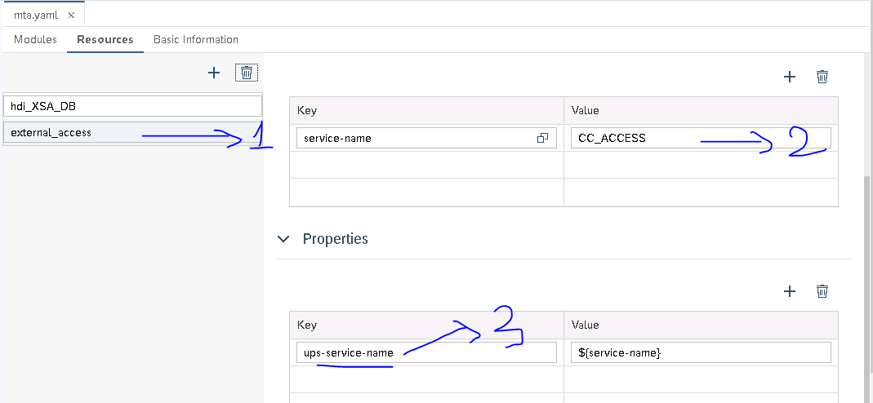

* **Adding the Resource name**
* **Passed the created user provided service name under the parameters key value section.**
* **Map the Created user provides service name to the key value which will passing in the module to section for connecting the Classical and HDI containers**

**5).** Pass the key value pointing in the properties section in the module section of key service

**Note -🡪 At any time If you change the key value inside the resource section of the Properties, (The Key value which holds through the Dynamic parameter) you must and should point the same name inside the module section of under the Service**

Now, attach this resource to the HDI DB module as a required resource, here we will need SERVICE_REPLACEMENTS Group to generate a key value for the service,

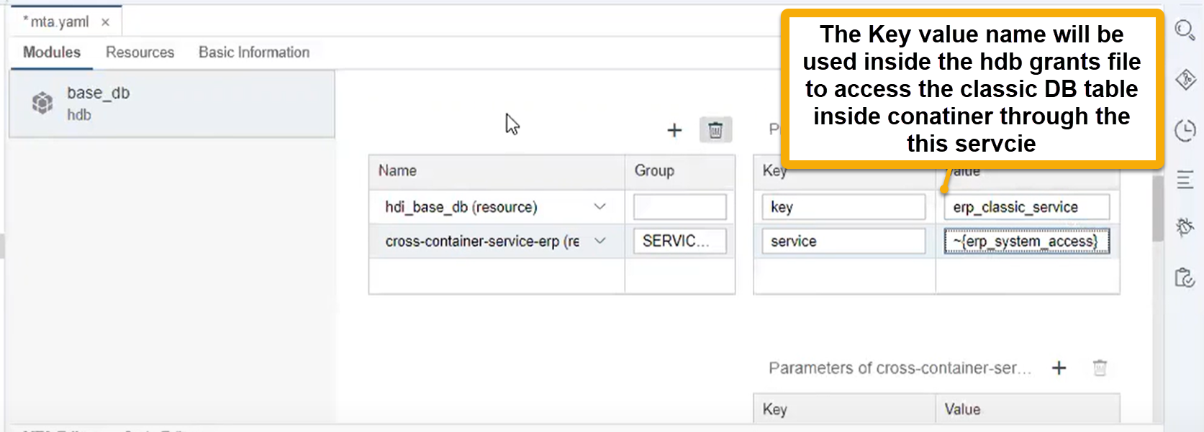

So, with that we can use this service key name in hdbgrants file to grant the access on objects in XS classic schema, key name will be same for all the developers and also in QA or production space**. Because, the service name which is generated during private build and actual deployment in a space is always different, but it is replaced with key value given in SERVICE_REPLACEMENTS GROUP. So it worked as ALIAS to the actual service name. We can see these service name after actual deployment is bound the DB module app in xs command line,**

# 

# 

6). Create the CFG **(Configuration File folder means the granted files)** outside the SRC (Source) folder because the files inside the configuration will execute first and then DB objects will be executed.

**7).** Create the **hdbGrant** file with below JSON data inside the CFG file

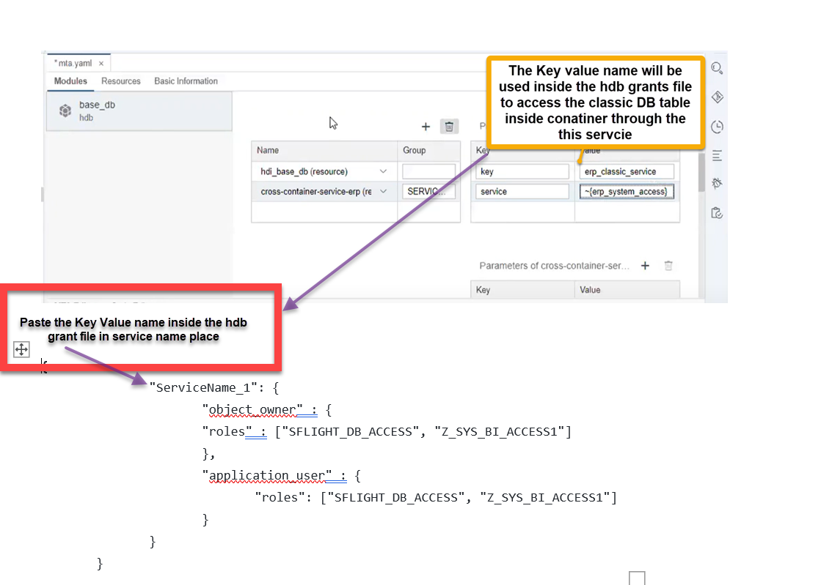

**OBJECT OWNER-🡪** Object Owner is the Owner who creates and delete the data base objects inside the XSA.

* Add the Roles that has been assigned to classical DB Table to Object Owner

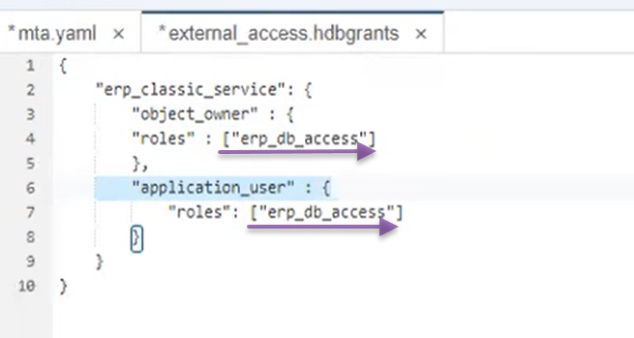

**APPLICATION OWNER-🡪**

**8).** This is the final step and in this step we will create **synonym and go to object name and select the CUPS service then select the table for which you want to create synonym.**

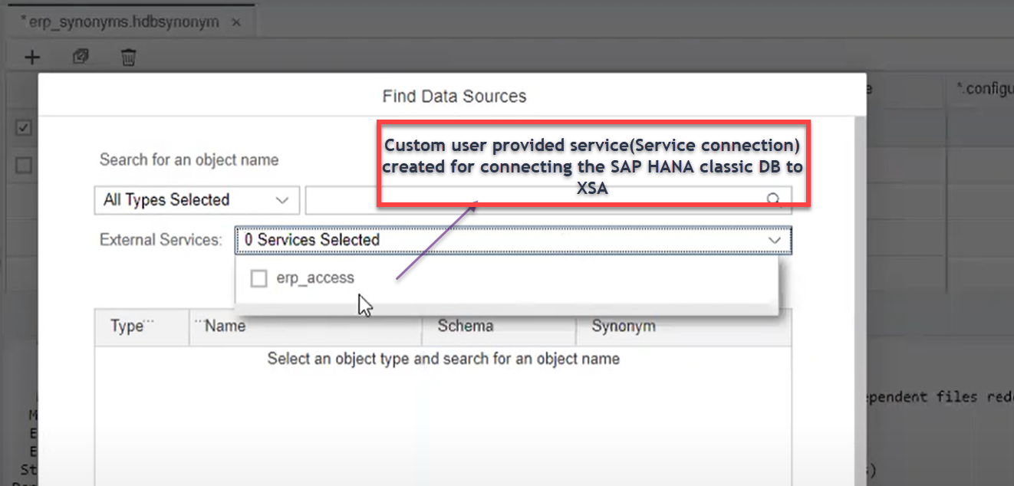

***SCENARIO 2***

**Cross Container DB access with in a Project**

There may be Scenario where in one MTA Project may have two or Three DB Modules inside a single MTA Project (SALES DB Module, CRM DB Module, FINANCE DB Module)

We can simply say **the Land Schema (tables)** and **Main Schema (consumable tables Mean EDW schema)** two schemas essential this two are two containers internally and both are isolated each other **and it’s can’t be possible to access to container 1 tables inside container 2 directly as the Isolated each other.**

* As the Landing DB container **(Container 1)** and EDW DB container **(container 2)** in one project itself so we don’t need to create the services to communicate each other the system will automatically understand accessing the other container based on **YAML file configuration**

Firstly, the staging module service will be attached to DW module, so that a connection is established, then container role will be created in Staging module, it holds the required privileges on Staging container. In the next step, a hdbgrants file will be created in DW module with role + service created in Step 1 and 2. Thereafter it will be same as in scenario 1, creating synonym and accessing it further.

**The Below pictures illustrating the flow of steps involved in accessing cross container tables within the same project.**

**Landing DB Module Target DB Module**

**Enable the Connection in YMAL File**

Container 1

Container 1

**Create the hdb.role file in Landing DB**

**Create the .hdb grnat file Target DB**

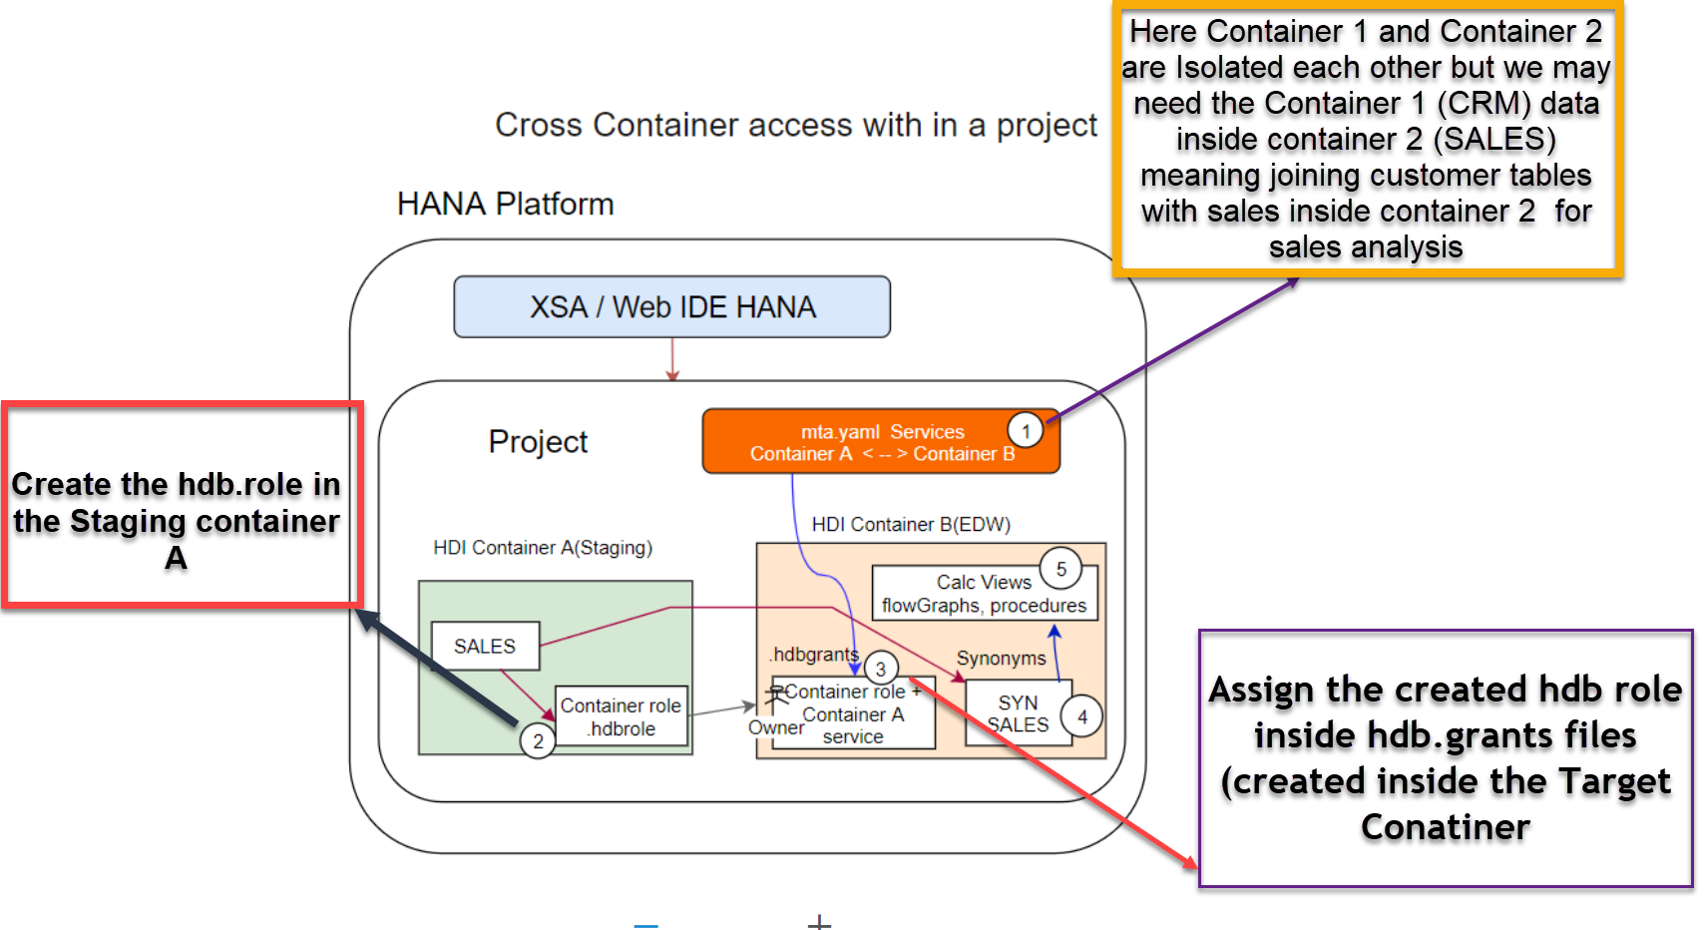

**1).** First step is configure the **resource service of the Land DB** to the Module section of the Target DB inside the required section (The require section of the Target DB module would requires the service of landing DB from resource of Landing DB to connect on)

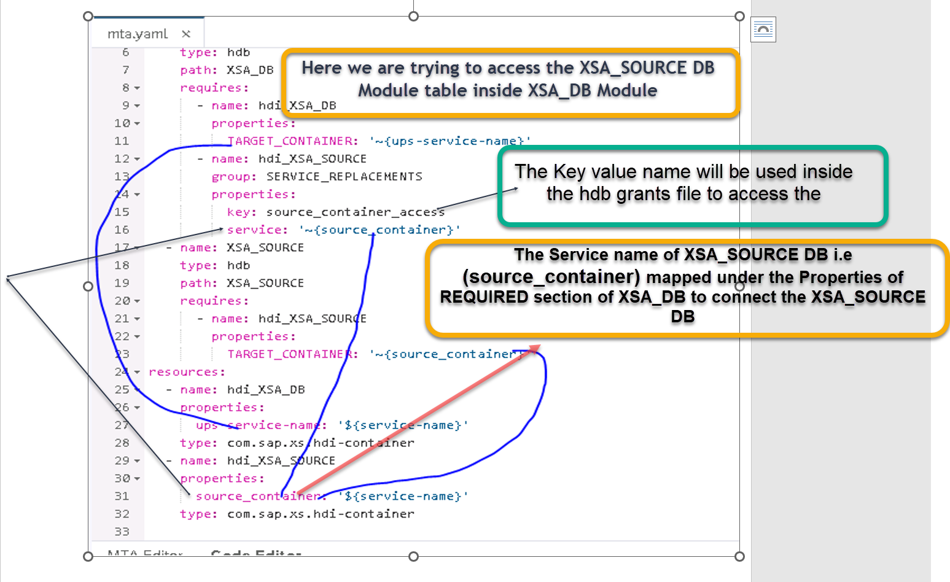

**2).** Create the hdb role for container inside the Landing DB Module . Here we are creating the Schema privilege with the grantable option

# 

**3).** Assign the Created hdb.roles to the hdb grants file(file created inside the Target Container) in the Target DB Module.

Specify the role name **container_roles** in the hdb grant file to assign the role that has been created in XSA_SOURCE DB module.

# 

**4).** This is the final step and in this step we will create **synonym and go to object name and select the service from the External Service drop down and then select the table for which you want to create synonym.**

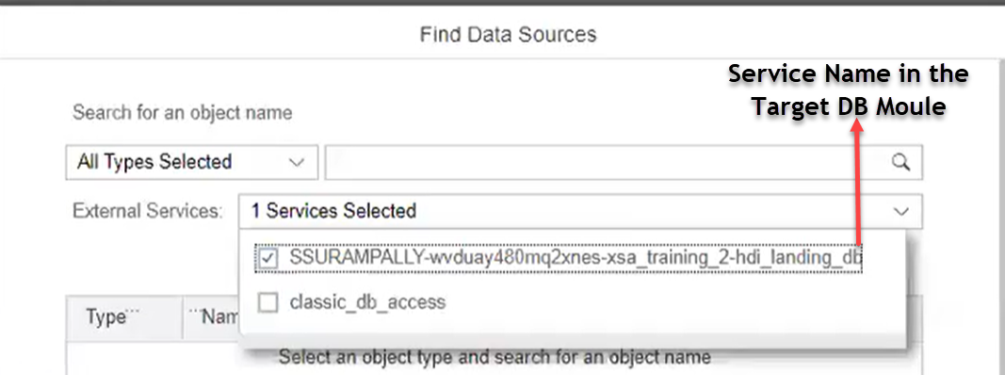

***SCENARIO 3***

**Cross Container DB access from Different Projects**

There may be Scenario where There will be a Two MTA Projects based on the incoming data **PROJECT CRM with CRM data** in the container and the other **PROJECT SALES with SALES Data** in the container

* As the CRM DB Module (**CRM_Container**) and SALES DB Module (**SALES_Container)** are not in the same Project and both containers resides in the different Projects so, The YML file will not able to connect two containers.
* As the YML file will not able to the connection containers, **we need the external service connection to connect.**

**PROJECT CRM PROJECT SALES**

**Enable the Connection by right click on the Project then NEW🡪SAP HANA service connection🡪HDI cont**

SALES_DB Module SALES_Container

CRM_DB Module CRM_Container

**Create the hdb.role file in Landing DB**

**Create the .hdb grnat file Target DB**

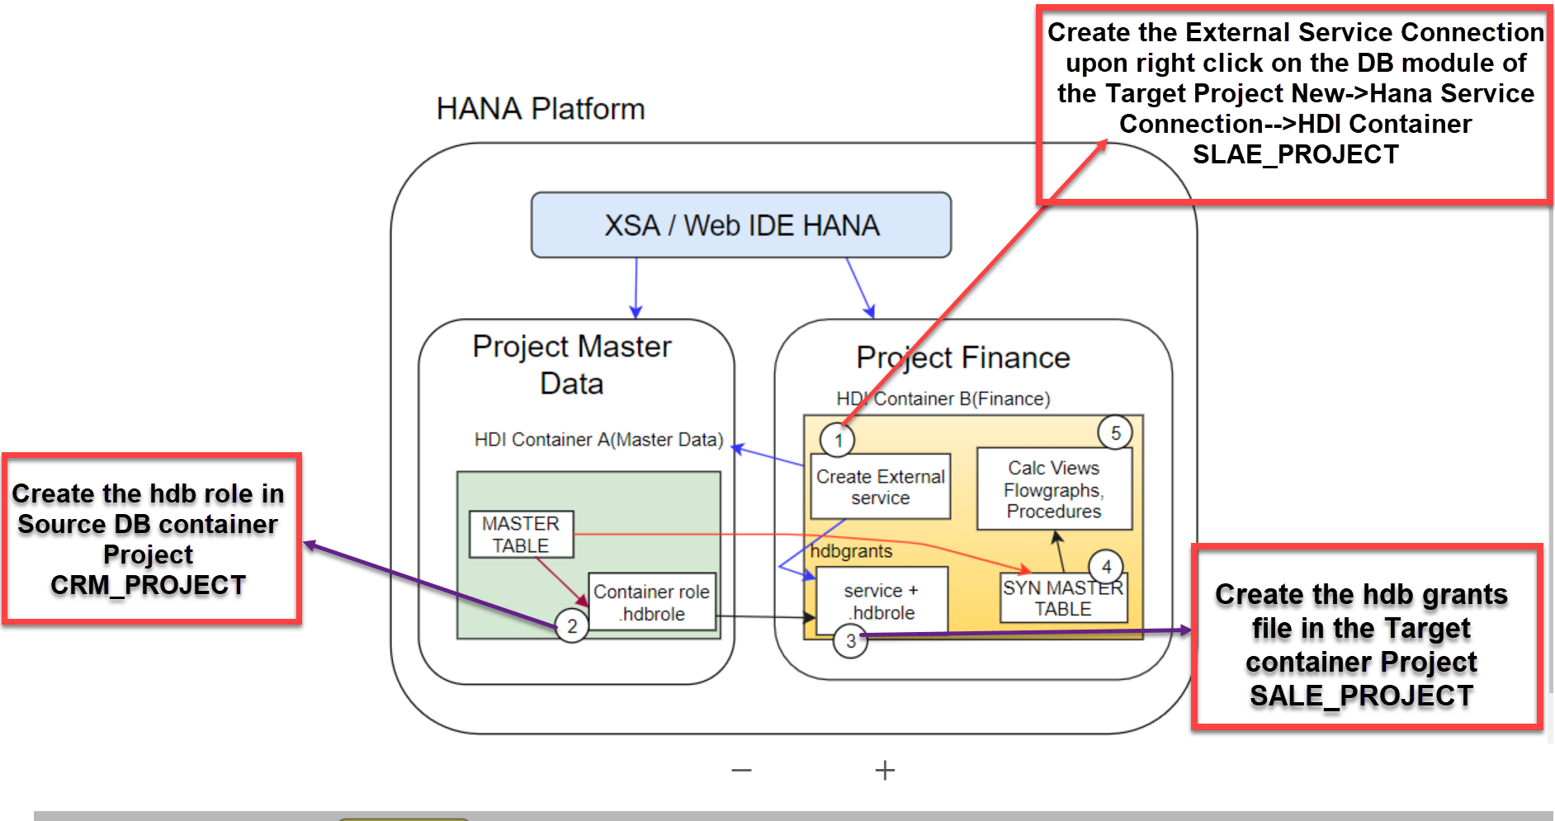

**1).** Create the external HANA service connection in the under the XSA_DB Module inside the XSA_PRACTICE MTA project

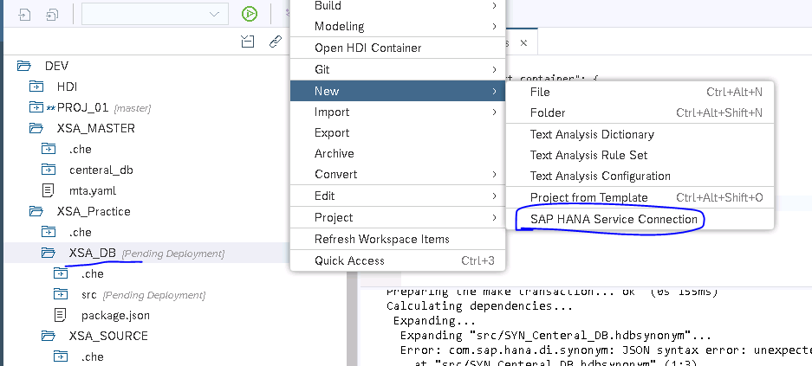

**2).** Select the HDI connect for creating the service connection as both the project DB containers inside the XSA repository.

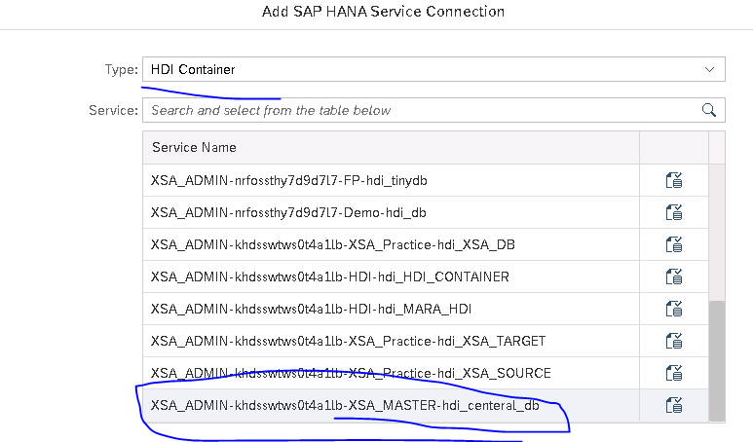

**3).** Create the .hdbrole file under the source DB module Project i.e XSA_MASTER Project with the required privileges.

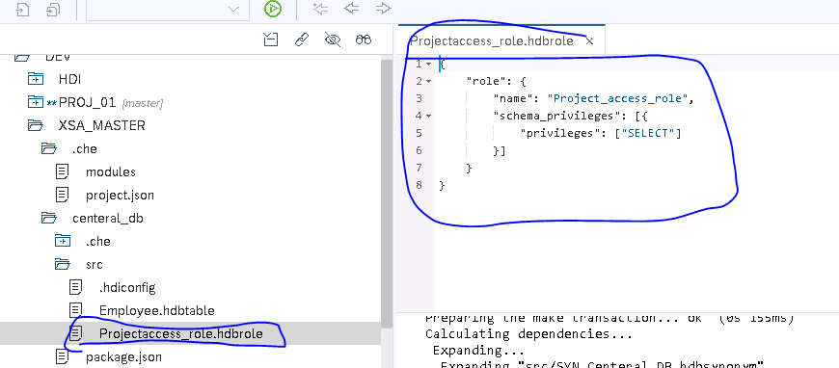

**4).** Assign the Created hdb.roles from the Source Project DB(XSA_MASTER) to the hdb grants file(file created inside the Target Container Project i.e XSA_PRACTICE).

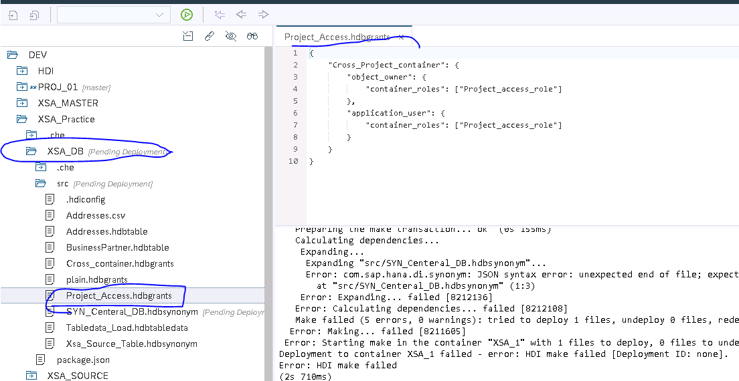

**5).** Follow the below steps and configure the YML files with the required information in the Resource and Module sections to connect the both the container projects

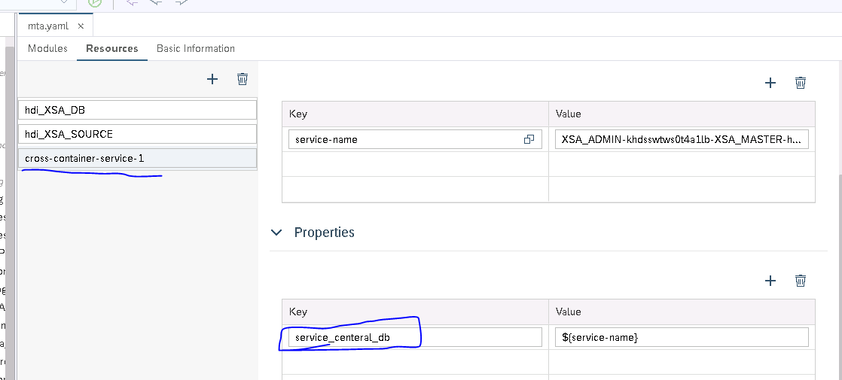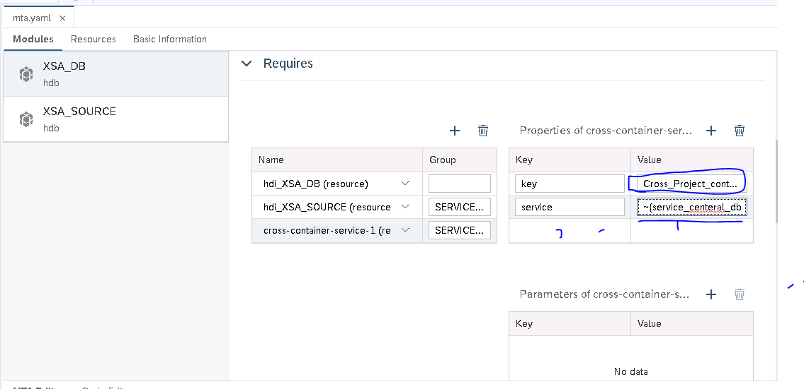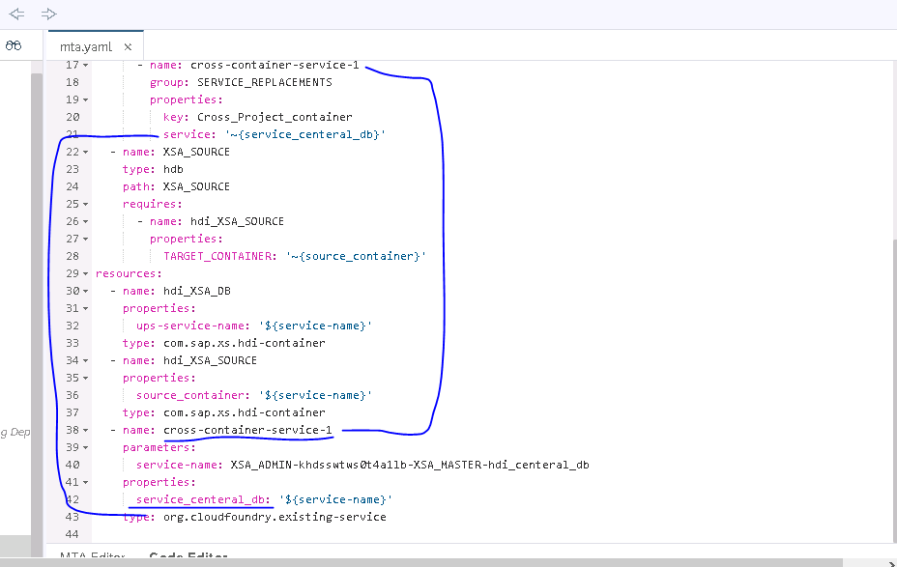

# 4). This is the final step and in this step, we will create synonym and go to object name and select the service from the External Service drop down and then select the table for which you want to create synonym.

# 

***SCENARIO 4***

**Accessing HDI container objects in Classic DB**

In this scenario, hdbrole will be created in Web IDE with all the required privileges on container, then we can use SAP standard stored procedures to assign this role to classic DB user, or you can also do manual grant of these role to classic user.

Running this procedure must be done in HDI Admin Console of DB explorer in Web IDE for HANA. That is it, classic user will get the required access to HDI container objects

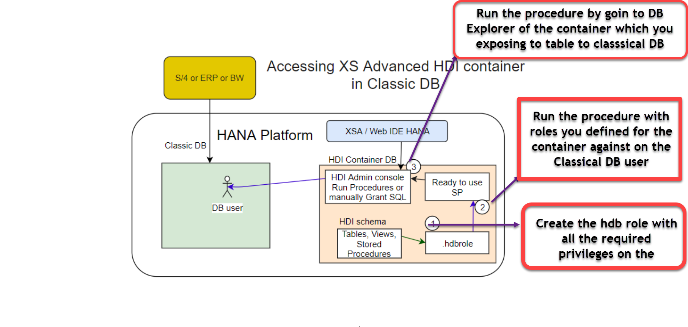

**It’s the process of calling the Procedure with the Admin access within the console by selecting open as Admin console.**

**1).** Create the hdb Role inside the DB module. Here we are creating the Schema privilege with the grantable option

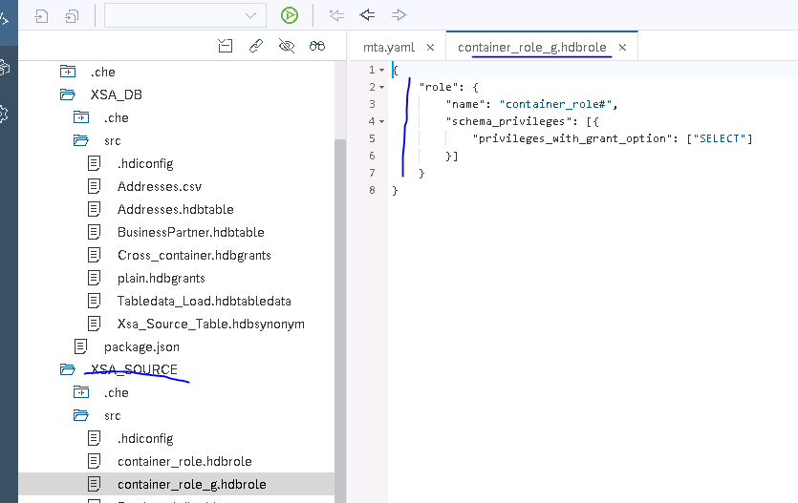

**2).** Go to container corresponding to the DB Module generated in the DB explorer and open SQL through the Admin console

**3).** Run the below steps in the admin console of the container to get the container schema in classical hana studio

In the DBA explorer of HDA container, open SQL console

set schema "MYAPP_HDI_DB_1#DI"; -- this is your HDI schema name

**create local temporary column table "#ROLES" like "_SYS_DI"."TT_SCHEMA_ROLES";**

---------- Here MYUSER is your classic database user name.

**insert into "#ROLES" ("ROLE_NAME", "PRINCIPAL_SCHEMA_NAME", "PRINCIPAL_NAME") values ('myapp.db::roles.myrole', '', 'MYUSER');**

--------- to grant the role

**call "MYAPP_HDI_DB_1#DI"."GRANT_CONTAINER_SCHEMA_ROLES"("#ROLES", "_SYS_DI"."T_NO_PARAMETERS", ?, ?, ?);**

**----------- to revoke the role**

--call "MYAPP_HDI_DB_1#DI"."REVOKE_CONTAINER_SCHEMA_ROLES"("#ROLES", "_SYS_DI"."T_NO_PARAMETERS", ?, ?, ?);

drop table "#ROLES";

-- Giving access to entire schema, instead of making it in a role,

set schema "MYAPP_HDI_DB_1#DI";

create local temporary column table "#PRIVILEGES" like "_SYS_DI"."TT_SCHEMA_PRIVILEGES";

insert into "#PRIVILEGES" ("PRIVILEGE_NAME", "PRINCIPAL_SCHEMA_NAME", "PRINCIPAL_NAME") values ('SELECT', '', 'MYUSER');

insert into "#PRIVILEGES" ("PRIVILEGE_NAME", "PRINCIPAL_SCHEMA_NAME", "PRINCIPAL_NAME") values ('INSERT', '', 'MYUSER');

insert into "#PRIVILEGES" ("PRIVILEGE_NAME", "PRINCIPAL_SCHEMA_NAME", "PRINCIPAL_NAME") values ('UPDATE', '', 'MYUSER');

insert into "#PRIVILEGES" ("PRIVILEGE_NAME", "PRINCIPAL_SCHEMA_NAME", "PRINCIPAL_NAME") values ('DELETE', '', 'MYUSER');

-- -----Providing entire schema privileges

call "MYAPP_HDI_DB_1#DI"."GRANT_CONTAINER_SCHEMA_PRIVILEGES"("#PRIVILEGES", "_SYS_DI"."T_NO_PARAMETERS", ?, ?, ?);

--call "MYAPP_HDI_DB_1#DI"."REVOKE_CONTAINER_SCHEMA_PRIVILEGES"("#PRIVILEGES", "_SYS_DI"."T_NO_PARAMETERS", ?, ?, ?);

drop table "#PRIVILEGES";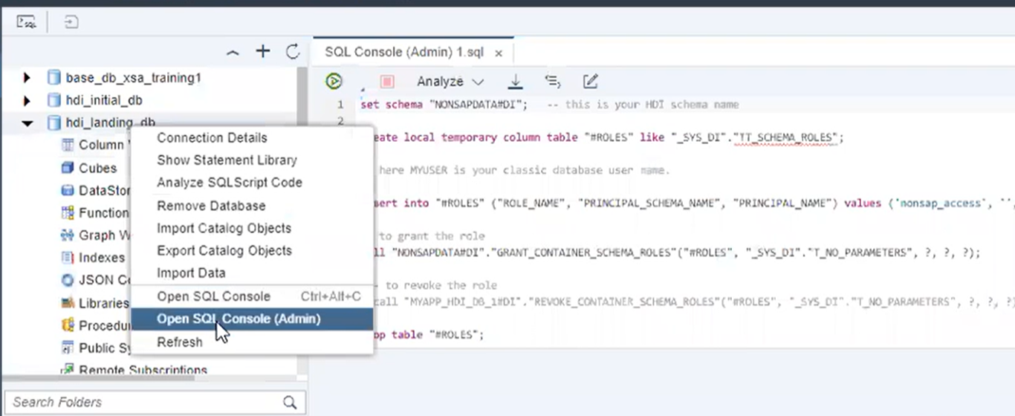

**DB Module Objects**

**Data Base Object Procedures and Functions**

This is the test scenario to call the procedures inside procedures and check the exception handling

1).Create the Table function with the 1/0 undefined error sql exception inside the function

FUNCTION "get_value" ( IN val INTEGER )

    RETURNS res DOUBLE

    LANGUAGE SQLSCRIPT

    SQL SECURITY INVOKER AS

BEGIN

/*****************************

    Write your function logic

 *****************************/

   res = 1/ (rand()*(:val-1));

END;

2.) Call the **get_value** function inside the debug_test procedure

PROCEDURE "debug_test"(IN inputtab TABLE(ITEMS Integer ),

                         OUT outtab TABLE(i INT, num DOUBLE)

)

   LANGUAGE SQLSCRIPT

   SQL SECURITY INVOKER

   READS SQL DATA AS

BEGIN

   /*************************************

       Write your procedure logic

   *************************************/

   DECLARE tempTable TABLE (i int, num DOUBLE);

   DECLARE i INTEGER = 0;

   BEGIN

       DECLARE EXIT HANDLER FOR SQLEXCEPTION

       BEGIN

            RESIGNAL SET MESSAGE_TEXT = 'ERROR in '||::CURRENT_OBJECT_SCHEMA||

                             '.'||::CURRENT_OBJECT_NAME||':'||::SQL_ERROR_MESSAGE;

       END;

       for i in 1..record_count(:inputtab) do

            tempTable.NUM[:i] =  "get_value"(:inputtab.items[:i]);

            tempTable.I[:i] = :i;

       end for;

   END;

   outtab = SELECT I, NUM FROM :tempTable;

END

3). Call the Anayze_error procedure with the debug mode and look the sql expectation in the debugger mode.

PROCEDURE "analyze_error" (OUT outtab TABLE(i INT, num DOUBLE)  )

   LANGUAGE SQLSCRIPT

   SQL SECURITY INVOKER

   --DEFAULT SCHEMA <default_schema_name>

   READS SQL DATA AS

BEGIN

   /*************************************

       Write your procedure logic

   *************************************/

   tab = select quantity as items from "PO.Item";

   call "debug_test"(:tab, outtab);

END;

**Long Running Procedure**

PROCEDURE "long_running_proc"(IN d INT,IN im_product_filter_string varchar(5000) DEFAULT'', OUT t1  TABLE (COL INT ),

                              OUT t2  TABLE (COL INT ))

   LANGUAGE SQLSCRIPT

   SQL SECURITY INVOKER

   AS

BEGIN

    DECLARE i int = 0;

    DECLARE tmp table (A nvarchar(20));

tmp.A[1] = 'dummy '||:i;

IF(length(:im_product_filter_string)) = 0 then

EXECUTE IMMEDIATE 'SELECT count(*) FROM "Products" where CATEGORY NOT IN (''Laser printers'')' ;

ELSE

EXECUTE IMMEDIATE 'SELECT count(*) FROM "Products" where CATEGORY NOT IN (''Laser printers'') AND '|| :im_product_filter_string ;

    end if;

CALL "log_proc" (::CURRENT_OBJECT_NAME, ::CURRENT_OBJECT_SCHEMA);

FOR i in 1..5 DO

tmp.A[:i] = 'dummy '||:i;

END FOR;

t1 = select * from "long_running_function"(:d);

t2 = select * from "long_running_function"(:d);

CALL "calculate_products" (im_product_filter_string => :im_product_filter_string,

                                EX_PRODUCTS => :EX_PRODUCTS);

t3 = select CUMULATIVE_SUM from :ex_products ;

    select * from :tmp;

    insert into "log.collectdata" (select * from :t3);

END;

**Long run proc**

PROCEDURE "log_proc" (IN name NVARCHAR(256),

                      IN schema NVARCHAR(256))

   LANGUAGE SQLSCRIPT

   SQL SECURITY DEFINER

   AS

BEGIN

        BEGIN AUTONOMOUS TRANSACTION

            INSERT INTO "log.info"

                 VALUES (current_timestamp, :name , :schema);

        END;

END;

See the Github for more examples.

**Active Procedures**

We can identify the long running procedures through the **M_ACTIVE_PROCEDURES by** passing the procedure name.

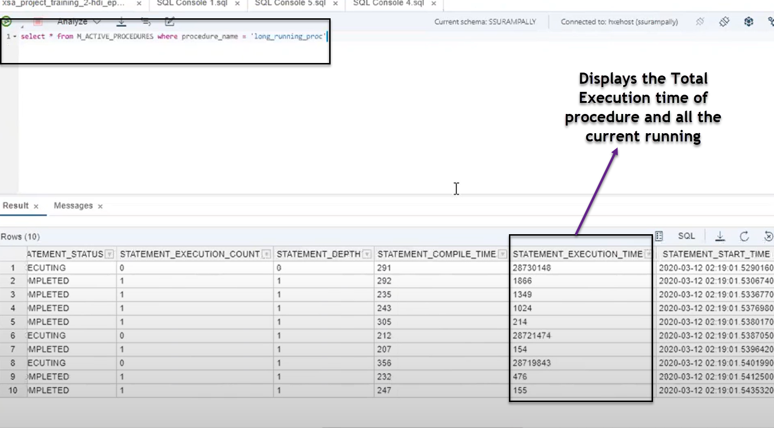

**Calculation Views**

**https://people.sap.com/jan.zwickel#content:blogposts**

In the HANA Classic the data base objects have been created by the SYS_REPO(Design time USER) and the run time calculation views will be owned by the SYS_BIC Schema.

There has been new operator is included in the SAP HANA XSA

* **MINUES**
* **INTERSECTION**
* **Graph**
* **Create Table Function**
* **Hierarchy Function**
* **Data Anonymization**

**Calculation view with Star Join**

The Calculation view with the star join will have the good performance because it prepares the execution of the joins at the parallel threads mode. It prepares the parallelized optimized query by the query execution. If your reporting has slice and daises analyses you can use the start join calculation view.

* Here in the SAP HANA XSA, the **Definer and Invoker** privileges can be based on the containers but on the SYS_REPO user.

Generating the M_TIME_DIM tables in SAP HANA XSA🡪**Right click on DB Module🡪 Modelling🡪Maintain Tables**

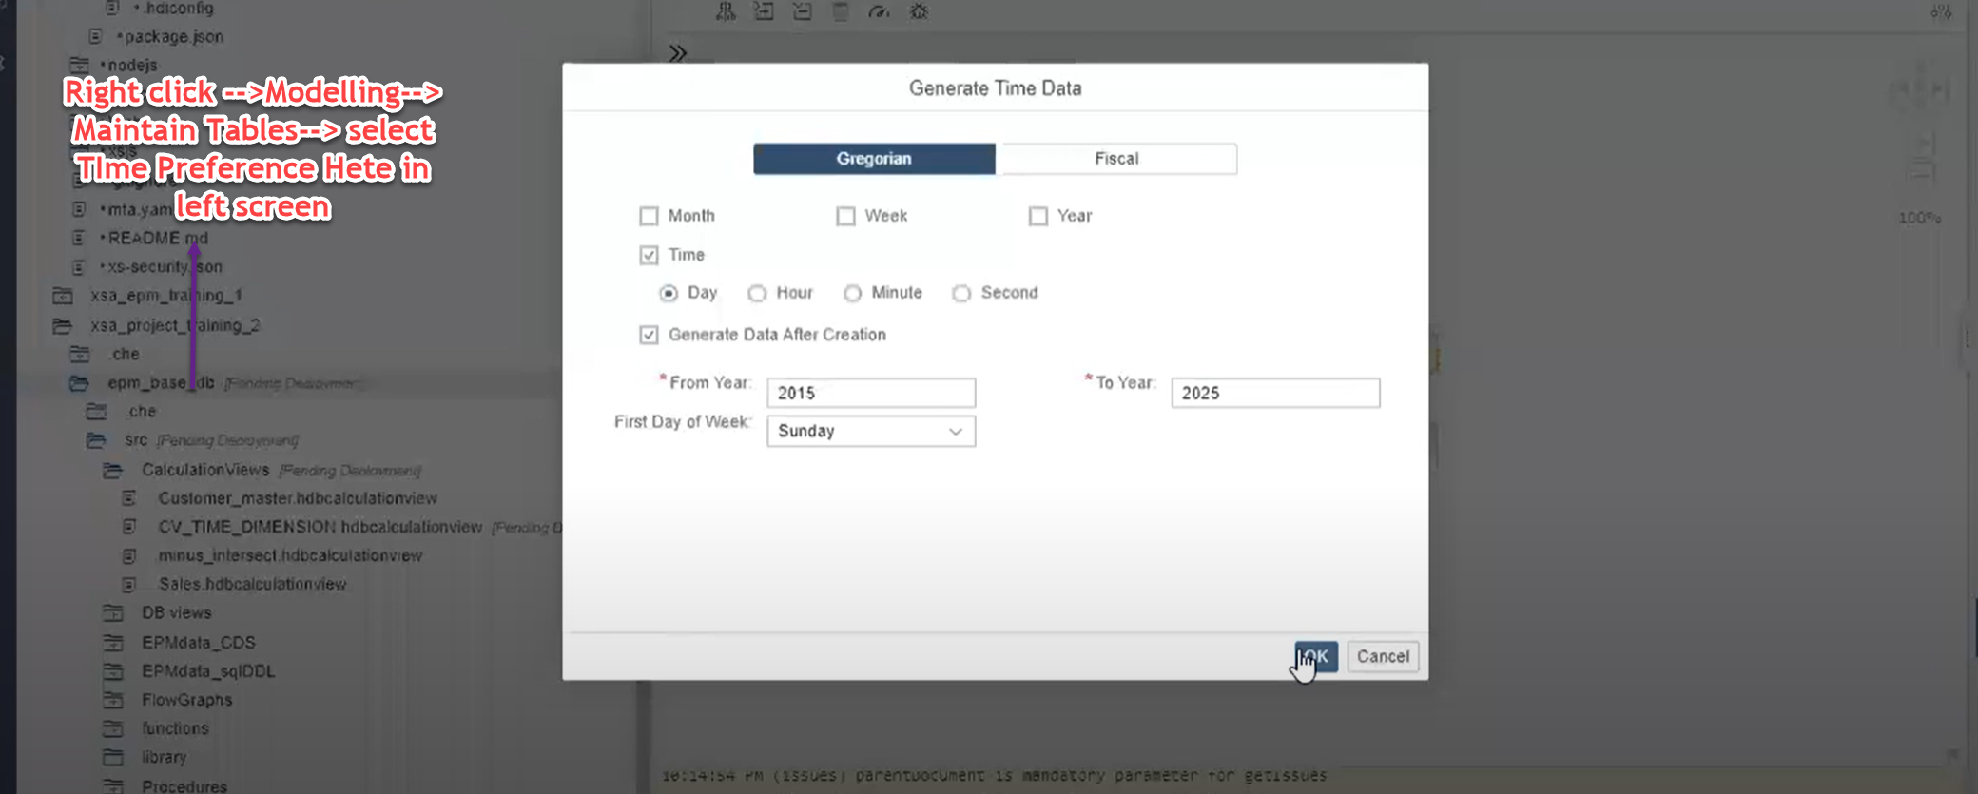

***Keep Flag: -***

Keep flag makes the column to be part of the client query(Is part of the SQL query ) keep the column in the query.

**Even though you are not requesting the column that has been specified as enable keep flag, but the still it will be part of the query imitation process in the upper queries or part of the external query.**

***Table Function: -***

In the XSA Classic using HANA Studio, we can have Table function used in either projection or Aggregation as a data source., but not as a direct node itself.

In the SAP HANA XSA Web ide the Table Function node is available as graphical node in the CV Calculation view.

Before introduction node, table function can be inserted in a **Projection or Aggregation**, it can’t have any node which can be used as data source to use in table function logic, the dataset will be derived in the table function explicitly by reading the other DB tables or CVs, and also more importantly, we can’t pass the input parameter with multiple values.

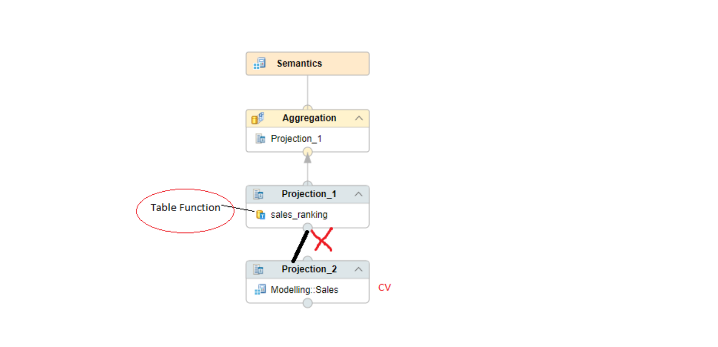

the above picture I have taken it from Web IDE, this behavior is same in HANA studio also., so you can’t have data source mapped to a projection which has table function in it. Of course, the result set of table function can be mapped to another node.

In the new feature, table function node, we can have a data source to table function node, the possible data sources can be a projection or aggregation or direct table or CV which is inserted into the TF node itself. You can see that from the below picture,

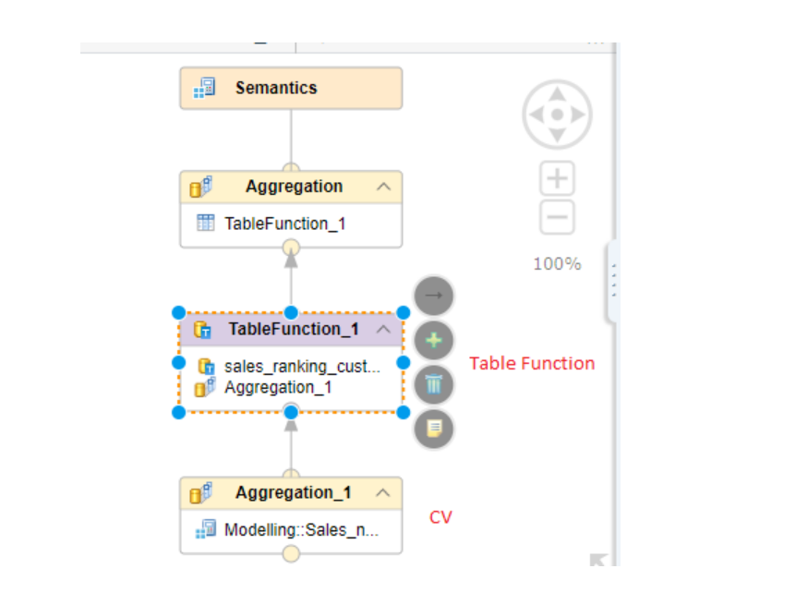

***Notes:***

1. if the table function is having scalar parameters, then it will be passed through input parameters in the CV.
2. A table function can be used as data source to table function node, which means, In the above example, aggregation_1 node can have table function also.
3. There can be multiple table function nodes in a graphical CV.

**Scenario🡪**

Here we are passing the table data as input parameter (IN TAB MYTAB TT_SALES) as the input to the TF and processes the logics inside table function based upon the incoming data and returns the data as output table.

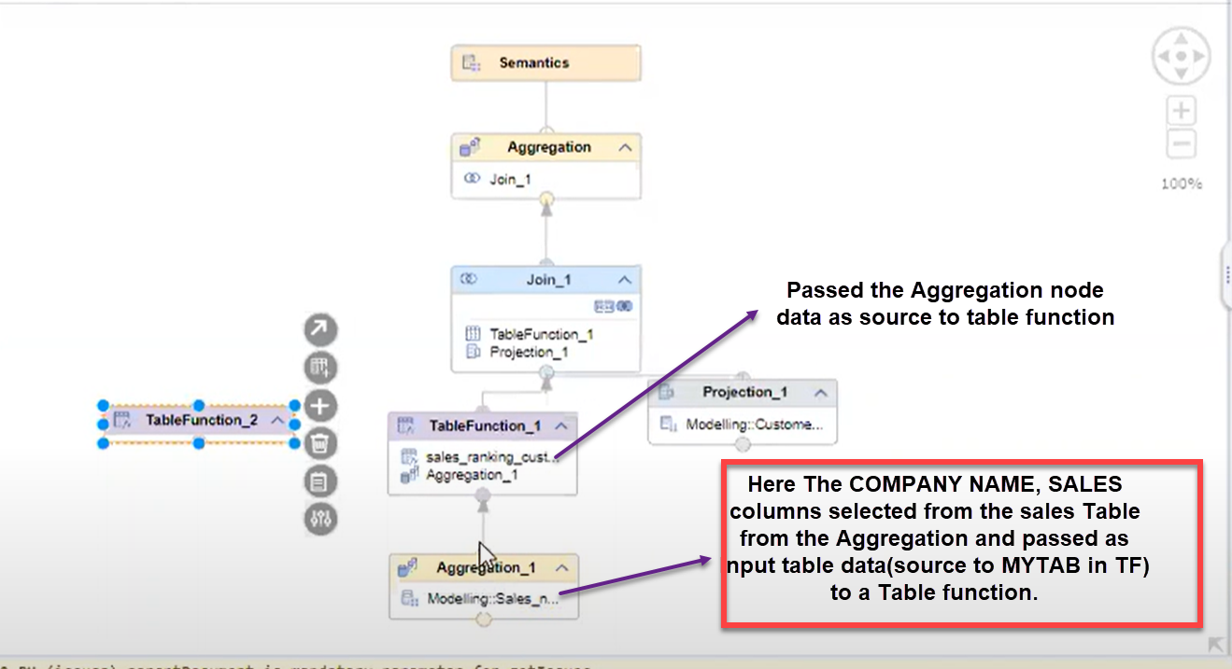

Here getting the source data to MYTAB to the Table Function from the calculation view Aggregation node.

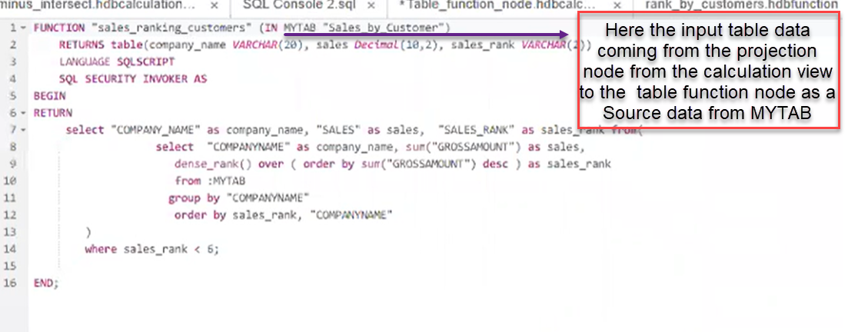

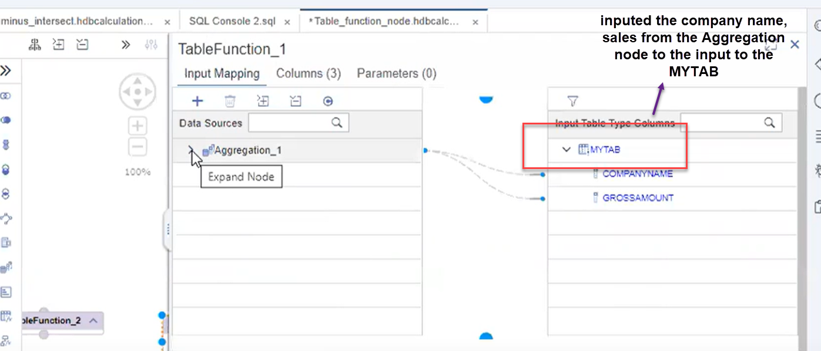

***Deployment in SAP HANA XSA***

Deployment 🡪Basic document to understand the deployment process

[***https://blogs.sap.com/2018/12/12/hana-life-cycle-management-for-xs-advanced-applications/***](https://blogs.sap.com/2018/12/12/hana-life-cycle-management-for-xs-advanced-applications/)

CTS for XSA🡪

[***https://www.sap.com/documents/2016/12/98ccd65a-9c7c-0010-82c7-eda71af511fa.html***](https://www.sap.com/documents/2016/12/98ccd65a-9c7c-0010-82c7-eda71af511fa.html)

Make unique name parameter for XS🡪

[***https://blogs.sap.com/2019/05/17/sap-web-ide-workspace-and-hdi-container-isolation-or-how-to-work-on-one-schema-with-multiple-developers/***](https://blogs.sap.com/2019/05/17/sap-web-ide-workspace-and-hdi-container-isolation-or-how-to-work-on-one-schema-with-multiple-developers/)

***Deployment command through CLI***

XS deploy c:\location\filename .mtar

In XSA each developer builds generates the schema name as _1 first developer, _2 Second Developer.

**In a Project if multiple developers are working then for each developer upon build of the DB Module an individual container will get generated and each one is Isolated with each other.**

**For each developer will work on his own copies of the objects and test the own data and with own scenario in his container without disturbing the other Developers.**

We can deploy MTAR file by right click on the MTAR file and deploy to XSA Advanced.

**We can do the Web ide development in Quality of Production system you can only do it in the Dev system of Web ide those are moved to Quality and Production through the MTAR file deployment process**

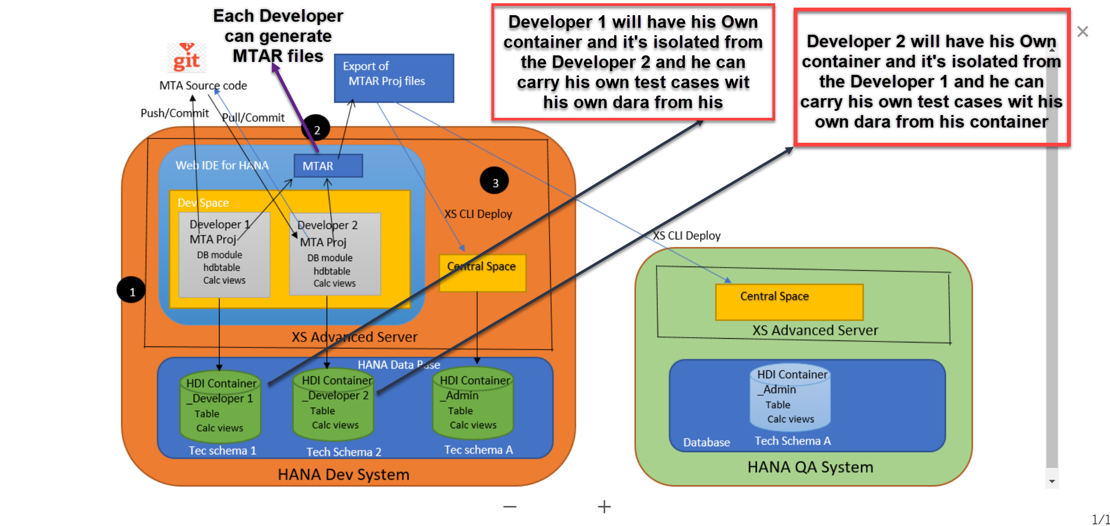

***Cloud Platform WEB IDE***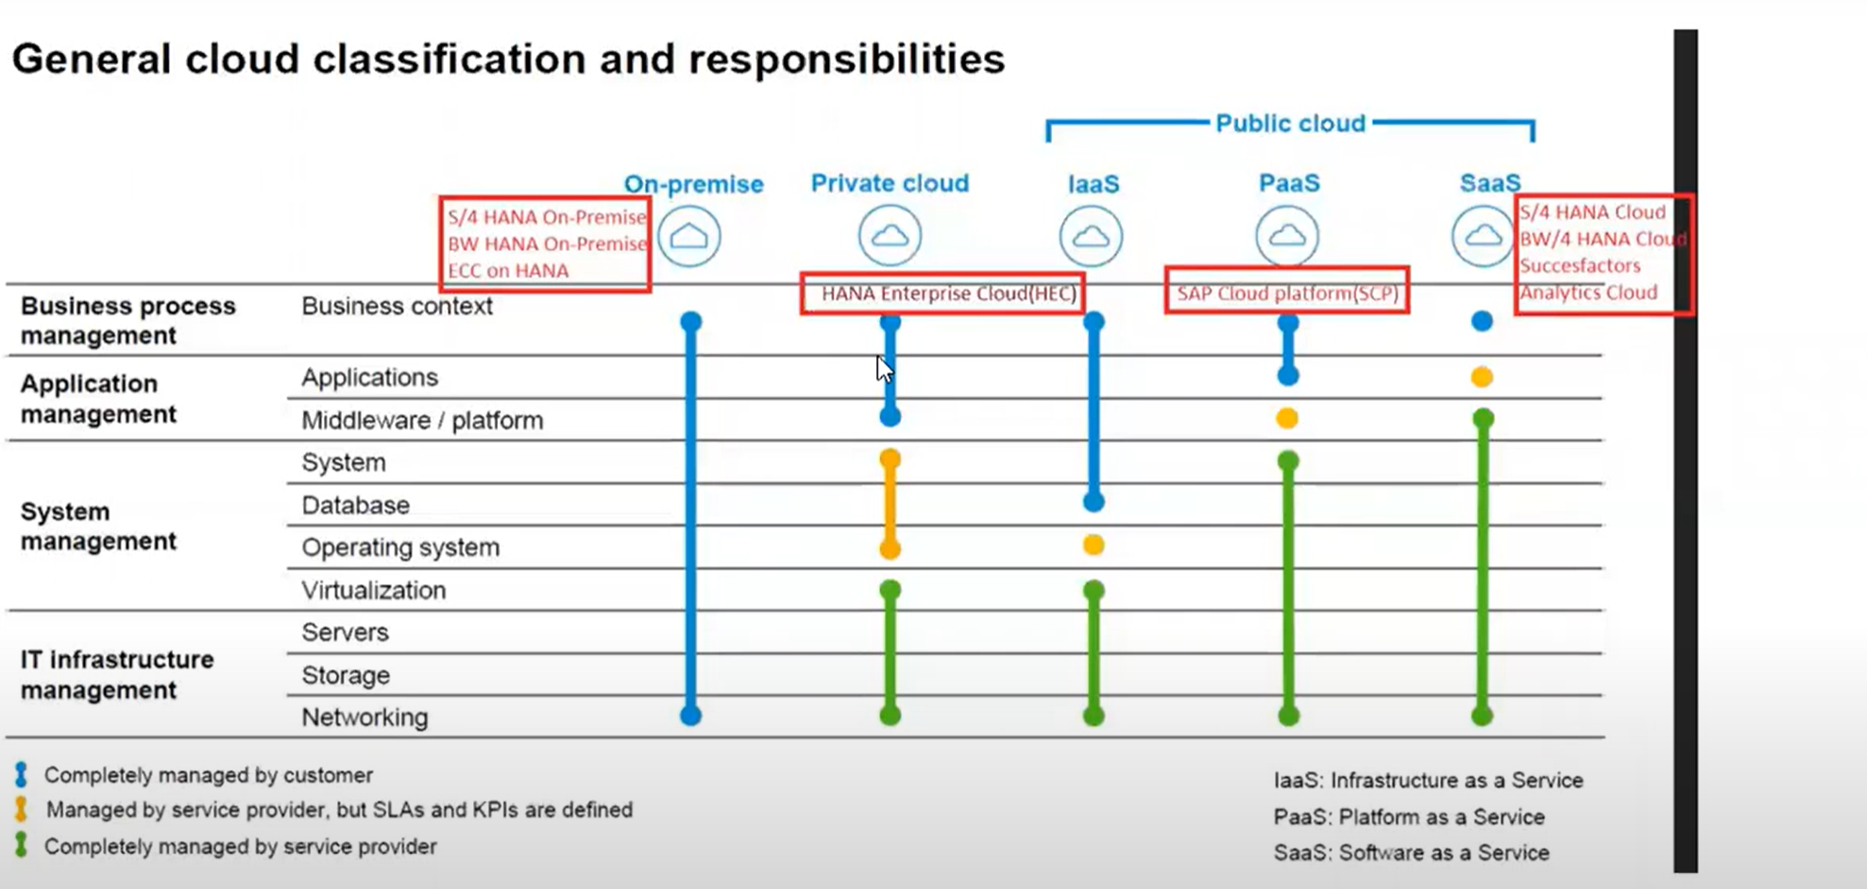

***APPLICATION DEVELOPMENT***

[*https://blogs.sap.com/2018/02/12/sap-teched-2017-cpl115-an-introduction-to-sap-hana-native-development-with-cloud-foundry/*](https://blogs.sap.com/2018/02/12/sap-teched-2017-cpl115-an-introduction-to-sap-hana-native-development-with-cloud-foundry/)

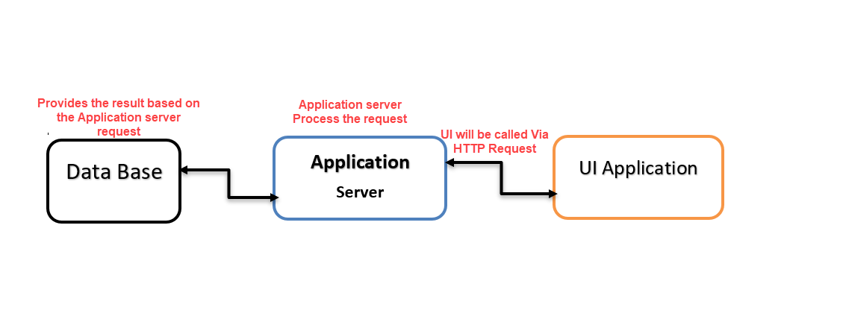

**All the Logics have been implemented inside the application server, based on Application logic the data has been retrieved and send back the result to UI**

***XSJS:-***

XSJS stands for server-side Java script, It is used in HANA to develop application logic, we can perform the below followings

**XSJS In XS Classic 🡪 The XSJS Run time environment is an Integral part of the XSA classic HANA server**

**XSJS In XSA Classic🡪**

# *Node Js*

**var arr1 = [1,2,3,4,5,6,7];**

**var arr2 = [78,99,98,12,45,90];**

**var callModule = require('./calling')**

**console.log ("Welcome to Node js")**

**callModule.printf(arr1);**

**callModule.printf(arr2);**

**-------Node Module Reusing ------**

module.exports = {

    printf: function(arrObjct) {

     for(var i=0;i<arrObjct.length;i++){

       console.log(arrObjct[i]);

     }

   },

   countArray: function(arrObjct){

     return arrObjct.length;

   },

   removal:function(arrObjct){

     arrObjct.pop();

}

}

**-------Node Fs Module Reusing ------**

var fs =require('fs');

var result =fs.readFileSync(__dirname +"/Sample/hello.txt","utf8");

console.log(result);

**The fs Module will read the Excel file you placed inside the sample file and display.**

**The Result will display in the hex decimal format, If you want to display in the proper readable format you need to include utf8 to decode the data and display charcterstic format.**

fs.readFileSync(__dirname +"/Sample/hello.txt");

**---Creating the New Directory and writing content to the directory**

var fs =require('fs');

var result =fs.readFileSync(__dirname +"/Sample/hello.txt","utf8");

fs.mkdirSync(__dirname+"/Vara");

fs.writeFile(__dirname+"/Vara/Testfile.txt",result);

**Building the Server Using the Node Js**

Request

**SERVER listening**

**Port – 8080**

**BROWSER**

**CLIENT**

Response

Application

**Header + Body**

**The response would be anything text, json,music anything it would be**

**The Browser sends the request and the response comes to client typically server listen the request.**

**Below is the list of the requests**

**GET-🡪 Read The data**

**POST🡪 Create New Data**

**PUT🡪 Update the Data**

**DELET🡪 Delete the Data.**

**Calling the Request and print data in the local server**

var express = require('express');

var app  = express();

app.get("/",function(req,res){

  res.send("The is a New server with the Node js");

})

app.listen(8081);

console.log("The server is running in the https://localhost:8081")

***Sending the response back to the Browser***

var express = require('express');

var fs = require('fs');

var app  = express();

app.get("/",function(req,res){

  var result = fs.readFileSync(__dirname + "/sample/hello.txt","utf8");

  res.send(result+"Hello");

})

app.listen(8081);

console.log("The server is running in the https://localhost:8081")

**The Express Module will used to send the request, response over the internet through the Node JS Server**

app.get("/",function(req,res)) 🡪 Will be used to get the request from the browser and send the response back to the client

  res.send(result+"Hello");--🡪 Sending the response to the client.

***Sending Login page as response back to the Browser***

var express = require('express');

var fs = require('fs');

var app  = express();

app.get("/",function(req,res){

  var result = fs.readFileSync(__dirname + "/sample/index.html","utf8");

  res.send(result+"Hello");

})

app.listen(8081);

console.log("The server is running in the https://localhost:8081")

***Sending the JSON data to Node Js server through the Postman***

var express = require('express');

var fs = require('fs');

var app  = express();

var bodyParser = require("body-parser")

app.use(bodyParser.json({

  limit: '50mb'

}));

app.get("/",function(req,res){

  var result = fs.readFileSync(__dirname + "/sample/index.html","utf8");

  res.send(result+"Hello");

});

app.post("/createEmployee", function(req,res)

{

  var data = req.body.data;

  if(data.empId> 10){

    res.send("Employee is Created" + req.body.data)

  }

  else {

      res.send("Employee ID is must be greater than 10");

  }});

app.listen(8081);

console.log("The server is running in the https://localhost:8081")

**The** var bodyParser = require("body-parser") Module will convert the incoming post man data into the JSON formatted format data

http://localhost:8081/CreateEmployee

Payload data

{

  "data": {

      "empId":113,

      "empName":"VaraPrasad",

      "salary":900

}}

**HTML5/UI5**

**USER INTERFACE**

**When We run each Module or app it will create the different micro services.**

**Each Micro service we can down or up individually**

**Micro-Services offered by SAP as part of the HANA Platform, or form cloud-foundry called backing service**

**Middleware –Node js,**

**Performs the Computation, Application Logic, Validations and DB Write and Read**

**Application layer SRV**

**DATA BASE**

**DB Module SRC**

**Architecture of the SAP HANA XS Advanced Programming Model with Cloud Foundry**

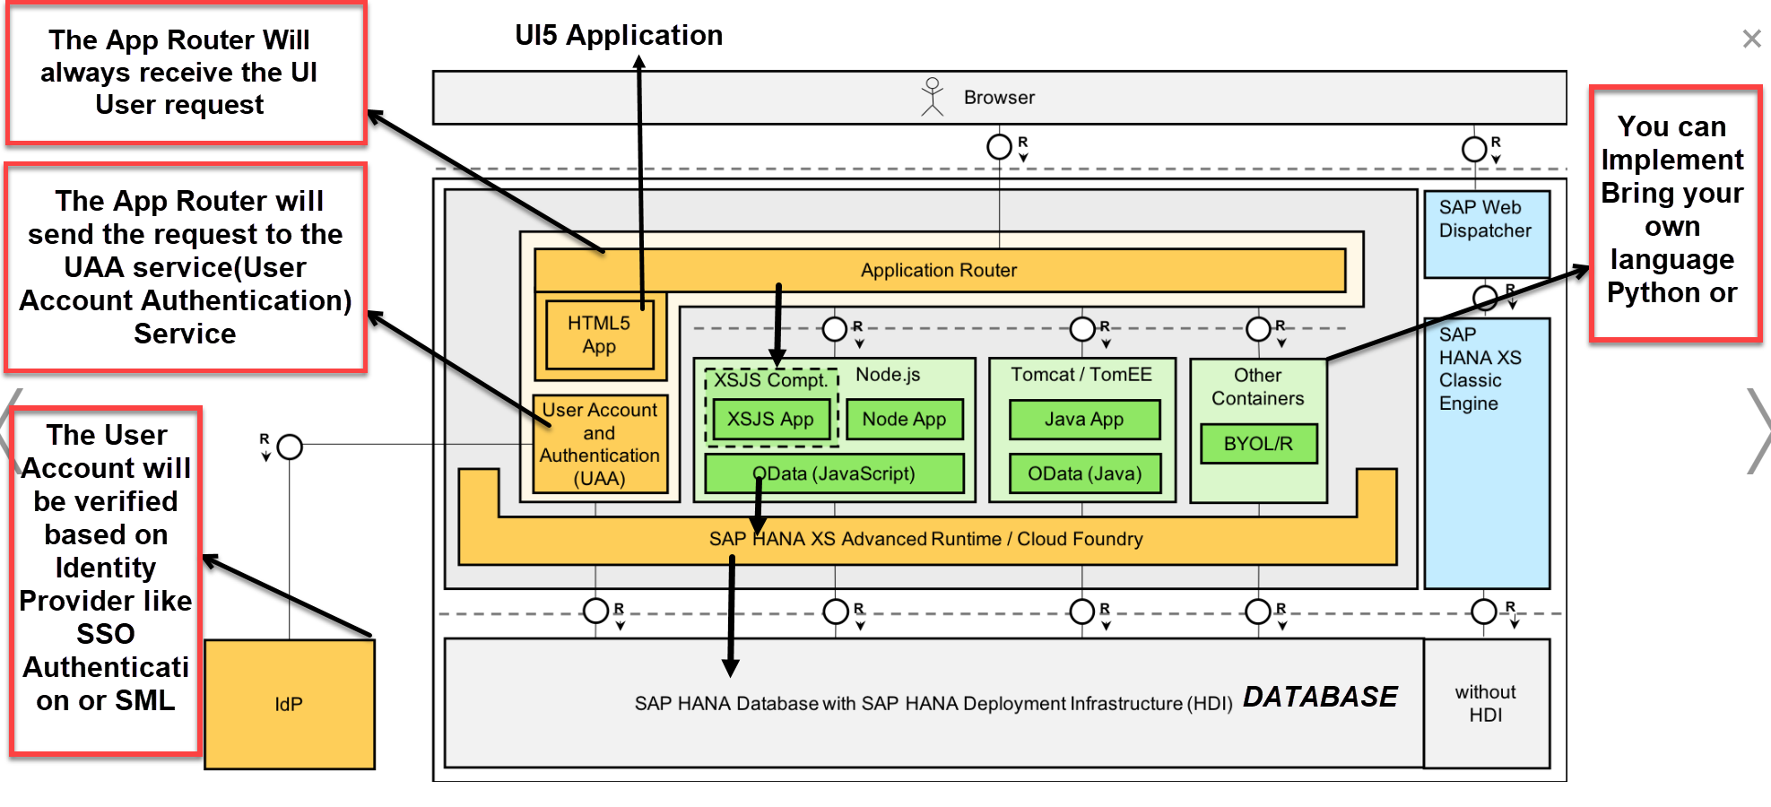

**Web Application Module**

The Web HTM5 Module will give us the we server and also gives the access to SAP UI5 libraries to allow create UI5 applications and Fiori applications.

The UAA service inside the Resource should be added in the Module section as required Resource to interact with DB and Node modules.

* Add the Web Module as soon as we add the web module corresponding yaml file is adjusted with the configuration files

# 

Once the Web Module is created by default the **RESOURCE** folder, **package.json** and **xsa-app.json** files will get created

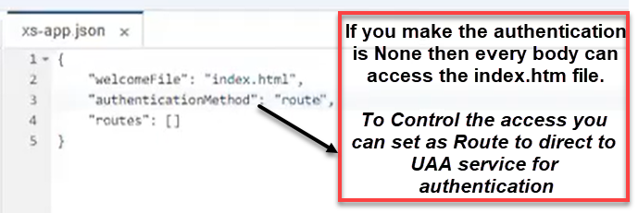

* In The second step we need to create the UAA service which will interact with web module to authenticate the Application user roles and access by means routers.

# 

Create the UAA service through the Service market place by going through the **Authorization & Trust Management**

# 

Create Service Instance like (HANA instance, User Provided service) as **UAA service by selecting as SPACE as plan.**

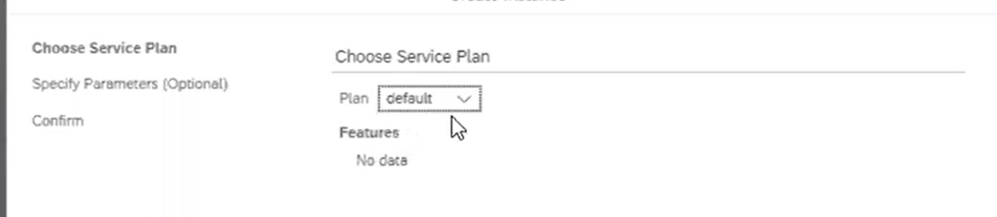

Attach the configuration file XS_SECURITY.JSON file while creating the UAA service inside the HANA Cockpit.

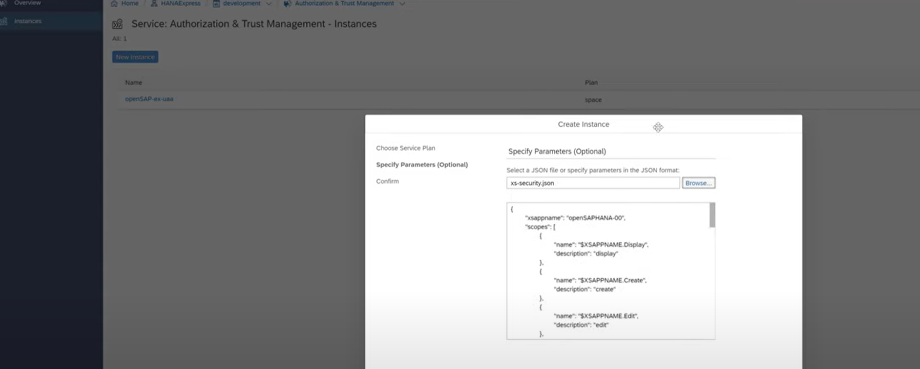

Provide the service name as per the name standards like XSA_UAA, UAA_AUTH then click on the finish and the service is listed in the New Instance list as like below depict.

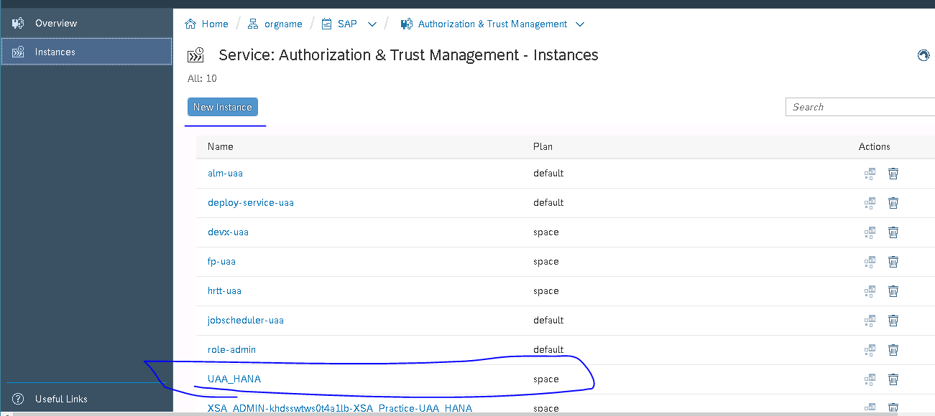

Created the UAA service by selecting the Space but it will have the plan and Devuser as well too

***Configuring the UAA service in YML file: -***

Once we created the UAA service we need to Map the UAA service inside the YML file resource section with the same name as the UAA name which you gave while creating the Service.

* Add the created UAA Service under the resource and select the Type for the service.

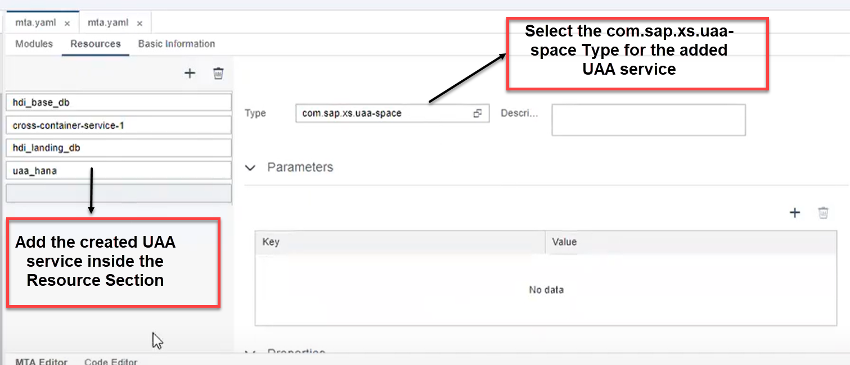

* Add the created UAA service under the module section of the requires

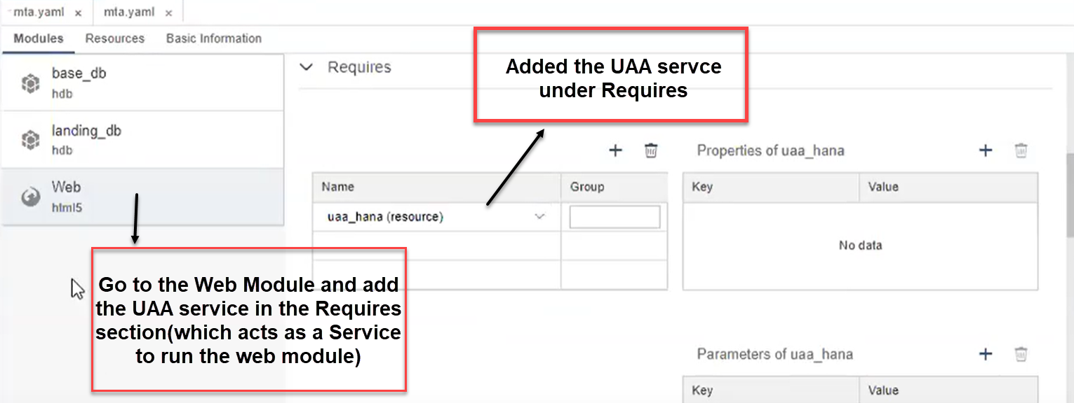

The Below URL has the guided steps for configuring the Web Module.

<https://developers.sap.com/tutorials/xsa-html5-module.html>

* Create the **xs-security.json** file to authenticate the via app Router.

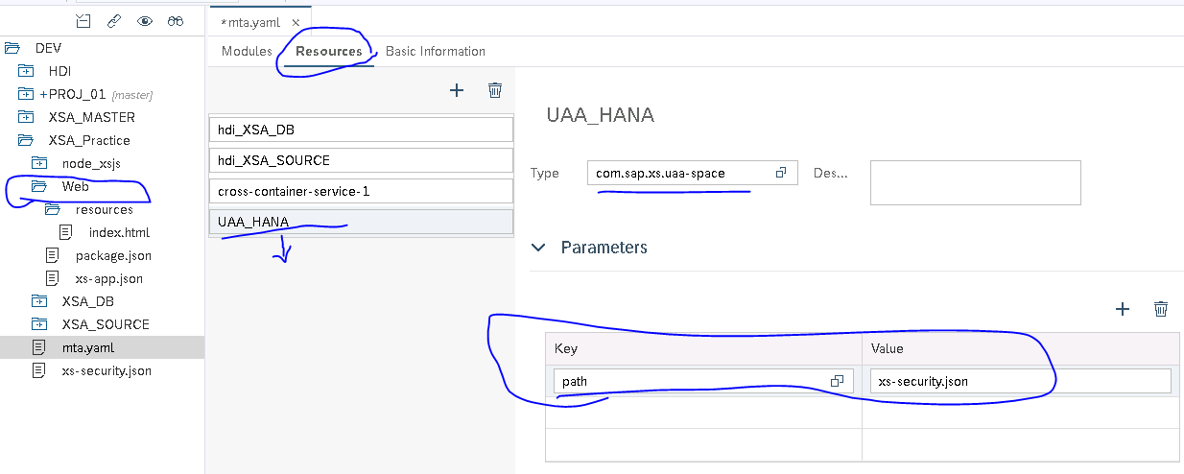

***Adding the Node JS Module to MTA Project***

Add the node js Module as soon as we add the Node module corresponding yaml file is adjusted with the configuration files

By default, the **server.js and package.js** files and also the index.js file will get created inside the Node JS module.

The Server.js file will have the connection details to connect to hana and UAA service.

***Sever.js file ->***

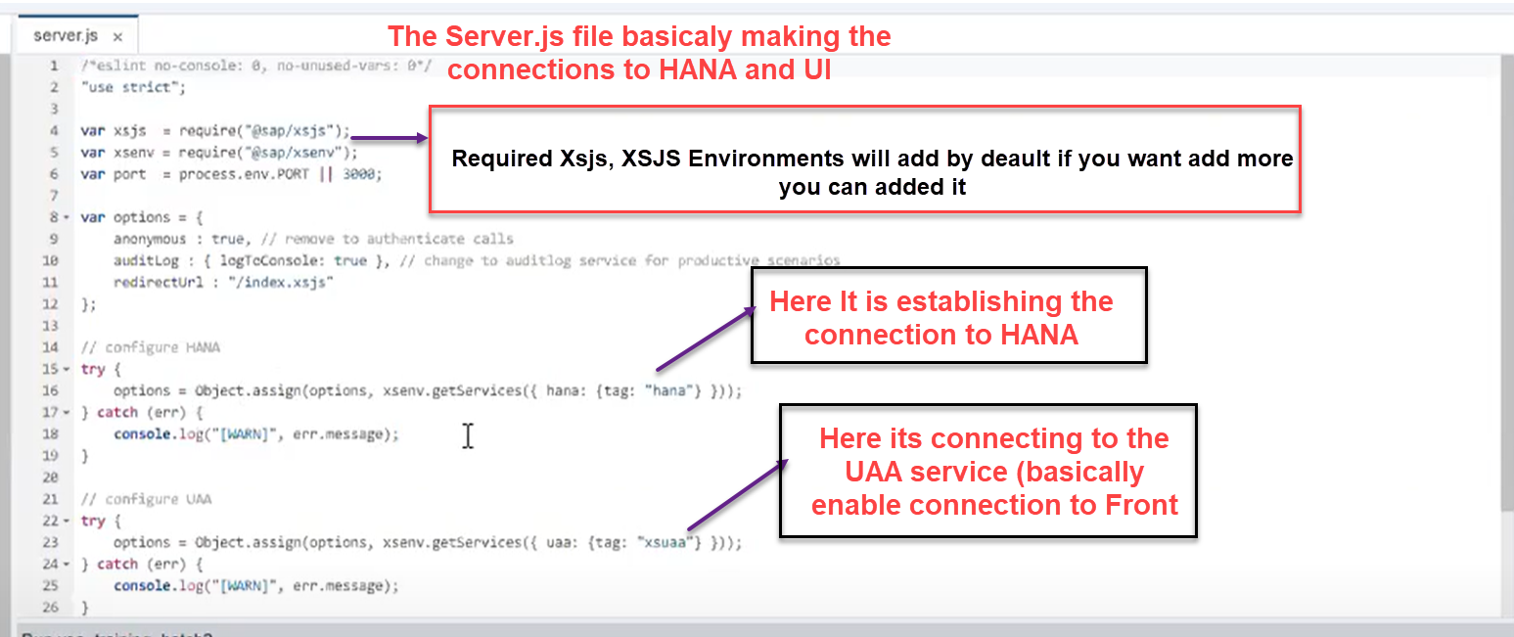

***Package.json file ->***

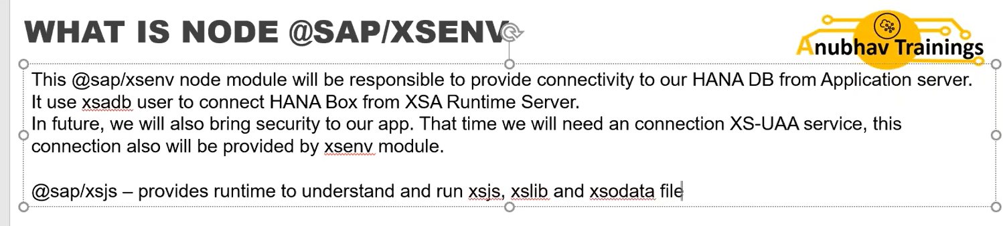

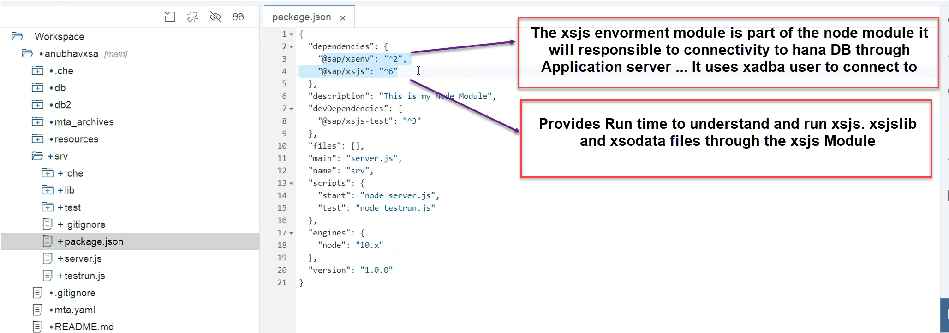

Package.json basically identifies the main entry point into the application of the start point.

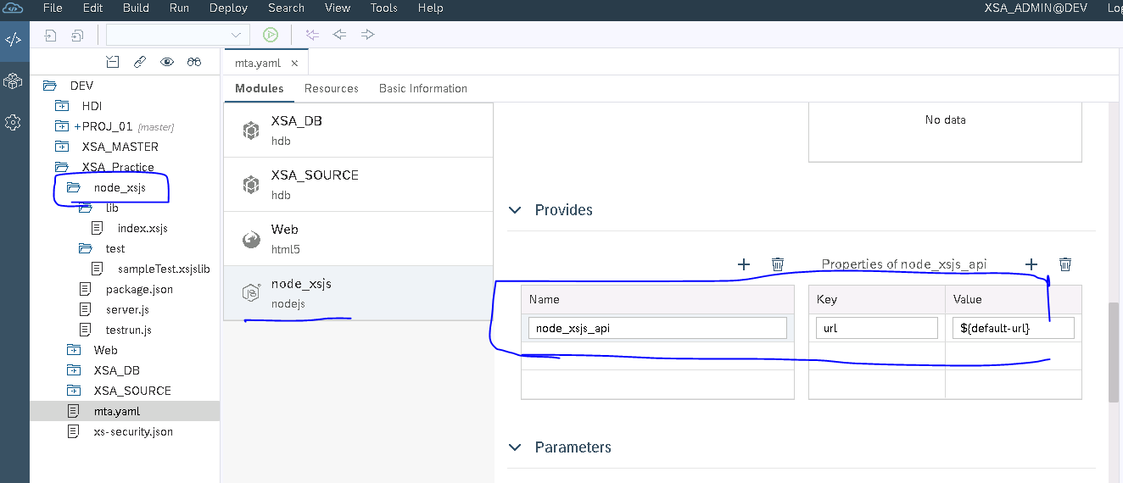

As soon as you add the Node js module the module section of node js module will have some default settings in the Provider section and same is highlighted in the above pic.

* Second step we need map the UAA service which you created for the authentication in the module section of the node js module to interact with the web module

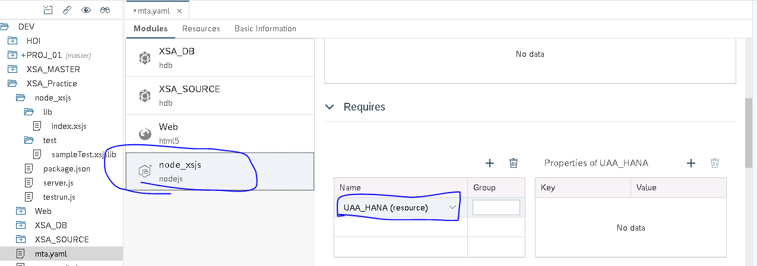

* Third step we have map the node js module in the web module in order to handle the node js request response to the web module (meaning getting the data from db module to web module)

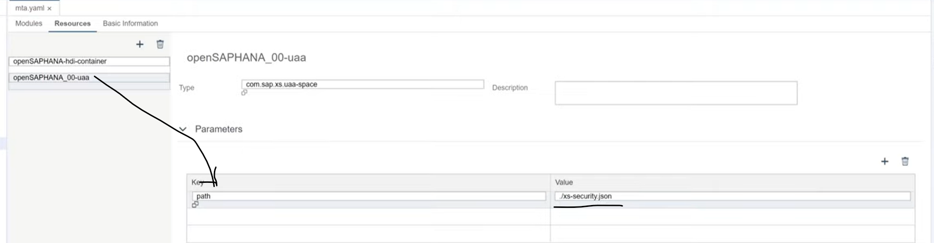

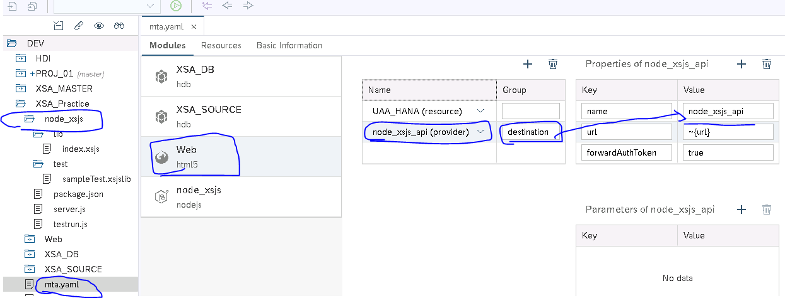

**Both the Web and Node Module will have the single point of entry is the UAA Service connection to interact the Node and Web Module each other**

The Forward Authentication Token as the “True” in the Xs_app. Json file but we didn’t specified through which route it has to go.. In order do that you should have to update the xs-app. Json file

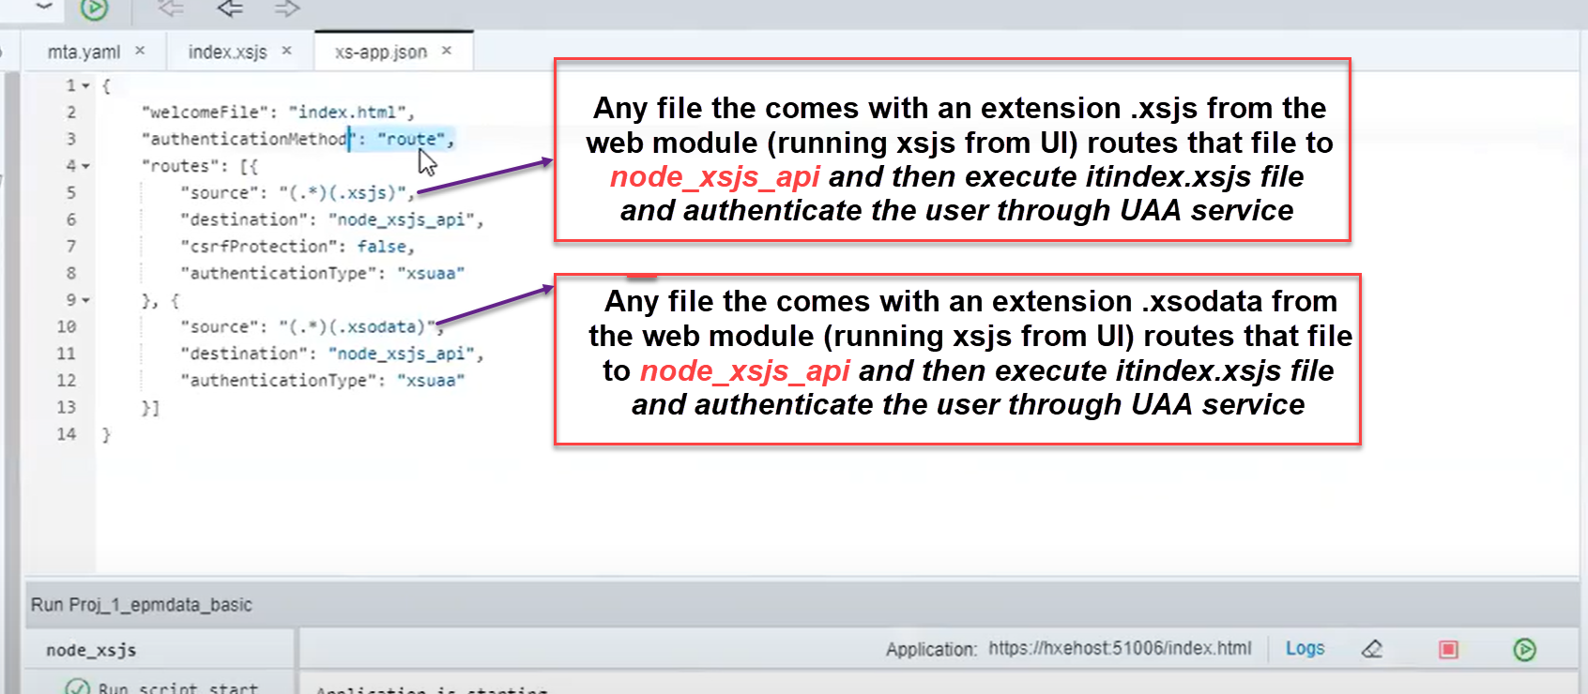

***Integrating the MTA Project***

In the Node js module the Server.js file have the configuration files for HANA connection and UAA service connection configuration details and have the password authentication dynamically.

This also the required xsjs and xsodata modules to load the data whenever the service call is triggered for the data from client side.

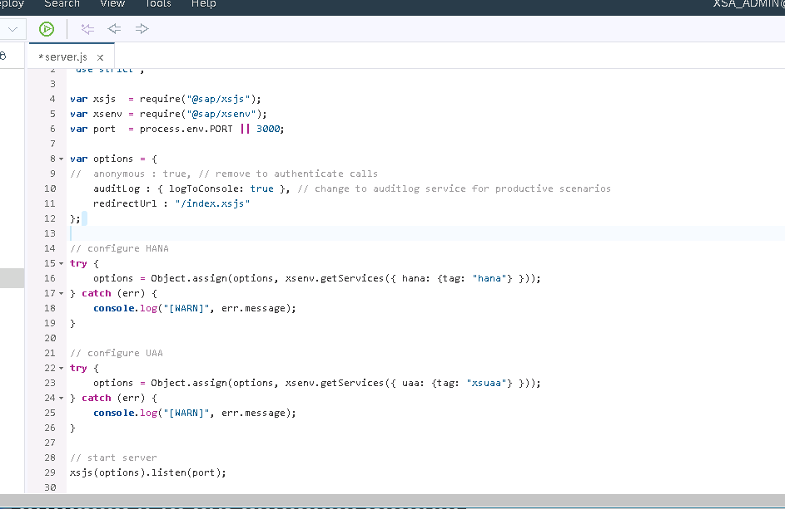

The created Node Js module should has to integrated with Web module in order to interact with the DB module to get the data and also to enable the restful API services to get the data as JSON format.

The Require Section of the module of the Web Module should has to configured with the Node_JS and Group name should be “destinations”

The group name destinations will tells internally from the web module to our XSJS module to where it has route.

The Group name destinations have the Properties Name and URL the Url we are not hard coding it rather than the we are using the built in variable to fill the URL dynamically at Deployment time.

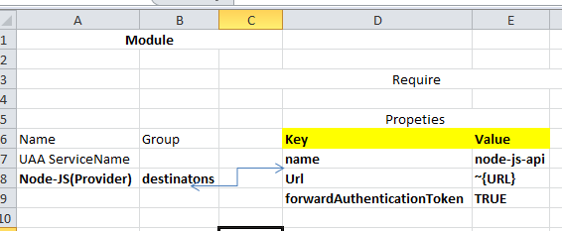

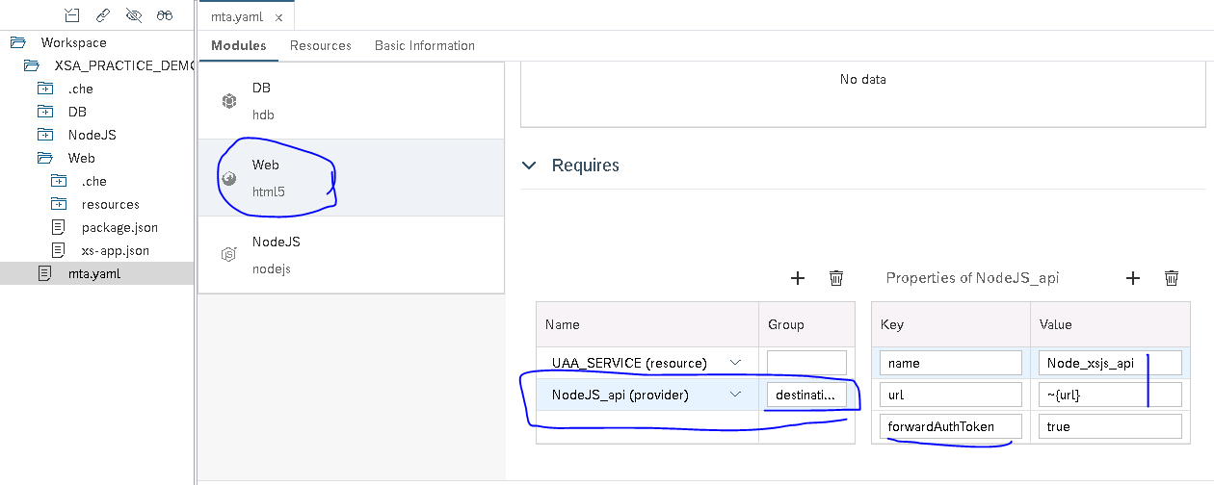

The Next step is to adjust the XSA_APP.js file with the routing with the rules mentioned below rules

Here any URL that ends with the .xsjs or .xsdata will then redirected to the node_xsjs_api api.

For the Both the XSJS and XSdata will files just apply the authentication method using the XSUAA service

***XSUAA Security: -***

**App Router**

* It’s a Node JS app
* It Provides the Single-Entry point to avoid CORS (cross origin resource) issue
* It allows redirect to correct resource of the app based upon incoming request
* To be able to tell app router, when to access which service we need to configure Routes
* These Roots are maintained in a specific file called **xs-app.js**
* Also acts as a OAuth Client to validate the token issued by XSUAA service
* The app Router will Receive a JWT Token with Scope information from UAA server about the User
* When use first time connect to the app Router, It redirect the user to the XSUAA server for Authentication

How the Web Browser request will be handled in XSA.

**{**

**"welcomeFile": "index.html",**

**"authenticationMethod": "route",**

**"routes": [{"source": "(.*)(.xsjs)",**

**"destination": "node_xsjs_api",**

**"csrfProtection": false,**

**"authenticationType": "xsuaa"},**

**{"source": "(.*)(.xsodata)",**

**"destination": " node_xsjs_api ",**

**"authenticationType": "xsuaa"**

**}]**

**}**

In the First step the Browser hit the the Node Js module to load the index.js file,

***SCOPES Security***

***https://developers.sap.com/tutorials/xsa-cap-add-uaa.html***

**Scopes are typical the permissions what are the access the user have like**

* **Can User will Display the data🡪 It’s a scope inside that what level you need to display the data**
* **Can User will Change the data**
* **Can User will Delete the data**

***Attribute Security***

**Attributes will define that within a given Scope what the USER is capable of doing... mainly the Attributes like Cost Center, Country & Profit Center**

**You can create the Role Template to simplify the SCOPE**

Countries, Cost Center, Profit Center data display, Edit and Delete

ATTRIBUTES

SCOPES

Create your Own Role Template and assign to the Scope

ROLE TEMPLATES

Display, Create, Delete

**All the Security actions has been taken care inside the XS-SECURITY.js**



**SCOPES** **can be assigned to the Roles templates and the Roles can be assigned to the users**

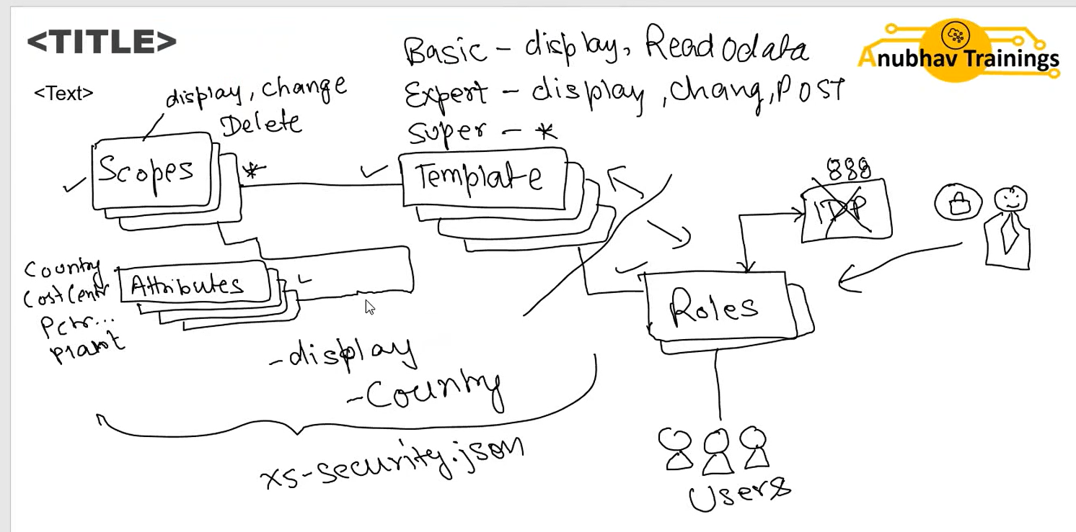



**The App Router Redirect the request to UAA Service**

**UAA SERVICE**

APP Router

**The UAA service authenticates the USER Account through the USER Authentication or Authorization**

**The Resource section of the UAA Service (Bind with XS-SECURITY.JSON file to authenticate based scopes**

**The Authentication is Done using the OAuth token**

**JWT Token will verify the type of the user and Roles of User**

XSJS Module

WEB Module

**JWT Token (JSON Web Token)**

Node/SRV Module

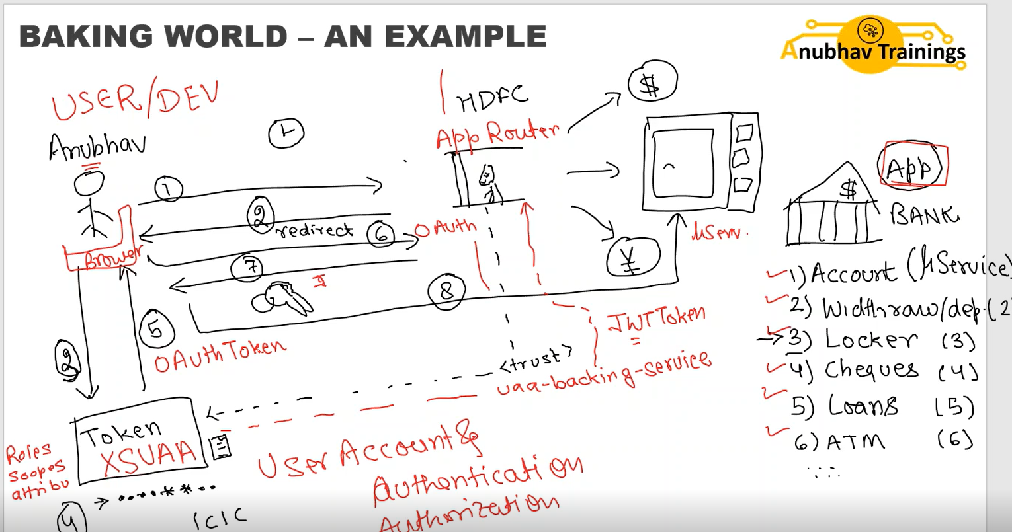

***Security Authentication Process Steps: -***

1) As the first step the request comes from the browser will be redirected to the App Router which prseneted in the XS_APP.js file

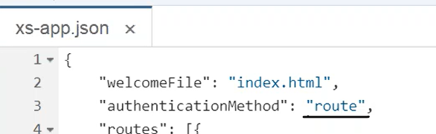

2) In this step the App Router check the OAuth token through the UAA service and if the token is valid and verified then the request goes to next step.

3) In the third step the O Auth validation is done along with the JWT token (JSON Web Token) validation will be performed meaning JWT token check what type of the user and the roles of the User.

4). Once the validation is completed the request comes through the app router and verifies if any of the file comes with .XSJS or .XSODATA will redirect the request to SRV module via XUAA service and displays the result

The csrf Token will identifies the user using the Tokens

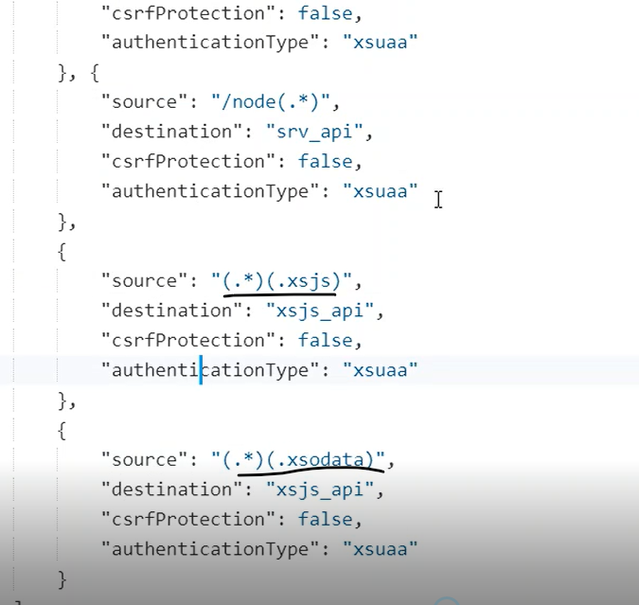

5). If the user doesn’t have the required Privilege or Permission to view the xsjs file or xs odata executed file data then you can terminate the user back with unauthorized access to data, This can be done inside the **XS_APP.JSON file through the $XSAPPNAME**

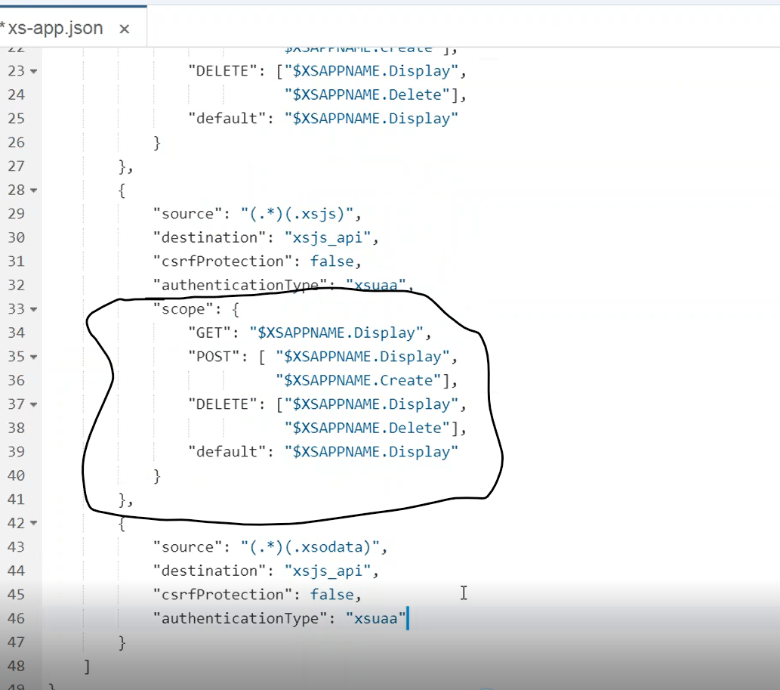

***XS_SECURITY.JSON***

{

  "xsappname": "openSAPHANA-ex",

  "scopes": [{

    "name": "$XSAPPNAME.Display",

    "description": "display"

  }, {

    "name": "$XSAPPNAME.Create",

    "description": "create"

  }, {

    "name": "$XSAPPNAME.Edit",

    "description": "edit"

  }, {

    "name": "$XSAPPNAME.Delete",

    "description": "delete"

  }, {

    "name": "$XSAPPNAME.DataGenerator",

    "description": "data generator"

  }, {

    "name": "xs_authorization.read",

    "description": "Read authorization information from UAA"

  }, {

    "name": "xs_authorization.write",

    "description": "Write authorization information to UAA"

  }, {

    "name": "$XSAPPNAME.ODATASERVICEUSER",

    "description": "Enter"

  }, {

    "name": "$XSAPPNAME.ODATASERVICEADMIN",

    "description": "Enter"

  }],

  "attributes": [{

    "name": "client",

    "description": "Session Client",

    "valueType": "int"

  }, {

    "name": "country",

    "description": "country",

    "valueType": "s"

  }],

  "role-templates": [{

    "name": "Viewer",

    "description": "View all records",

    "scope-references": [

      "$XSAPPNAME.Display"

    ],

    "attribute-references": [

      "client", "country"

    ]

  }, {

    "name": "Editor",

    "description": "Edit and Delete records",

    "scope-references": [

      "$XSAPPNAME.Create",

      "$XSAPPNAME.Edit",

      "$XSAPPNAME.Delete",

      "$XSAPPNAME.Display",

      "$XSAPPNAME.DataGenerator",

      "$XSAPPNAME.ODATASERVICEUSER",

      "$XSAPPNAME.ODATASERVICEADMIN"

    ],

    "attribute-references": [

      "client"

    ]

  }]

}

Imagine that the XS-SECURITY.JSON file is like House to the security will enforce the security like only allow through the main (View), Allow the Men through the locker Key, Allow and use the utensils to cock something this sort

***************SECURITY******************

The UAA service make sures that the User is Authenticated User and eventually if the User has the authenticated, The robust security has been added to check the securities to know the Operations like Display, Get, Update, Delete operations

MTA.YML

RESOURCE

MODULE

REQUIRES

**WEB**

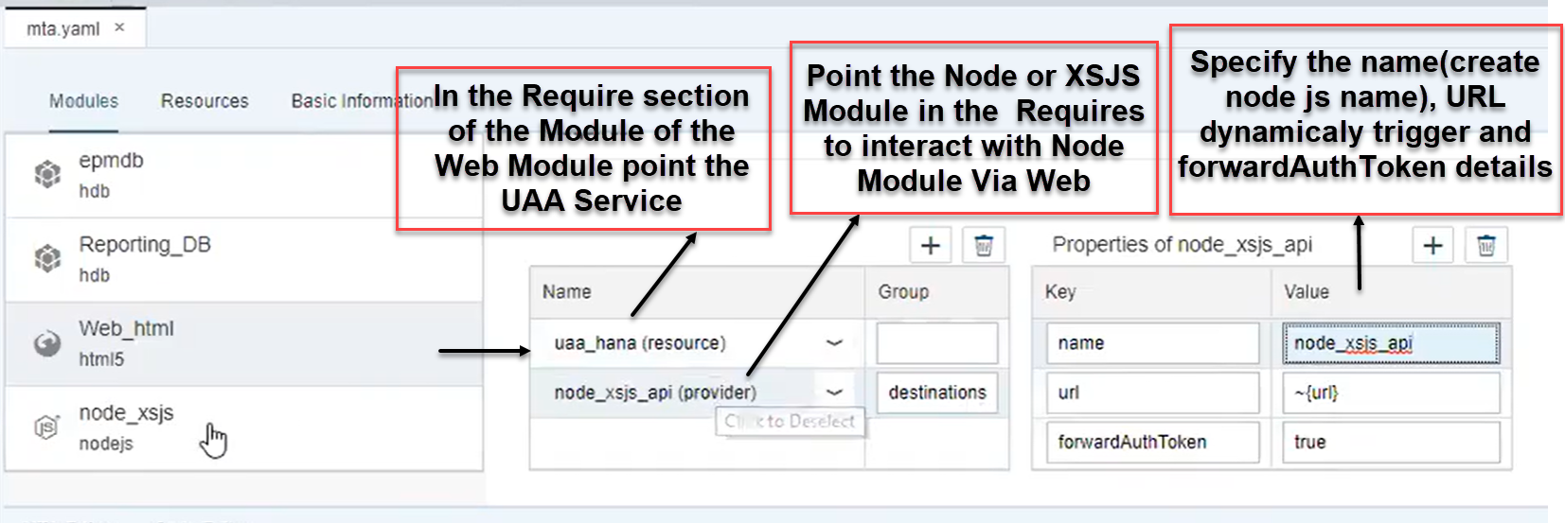

REQUIRES

**NODE JS**

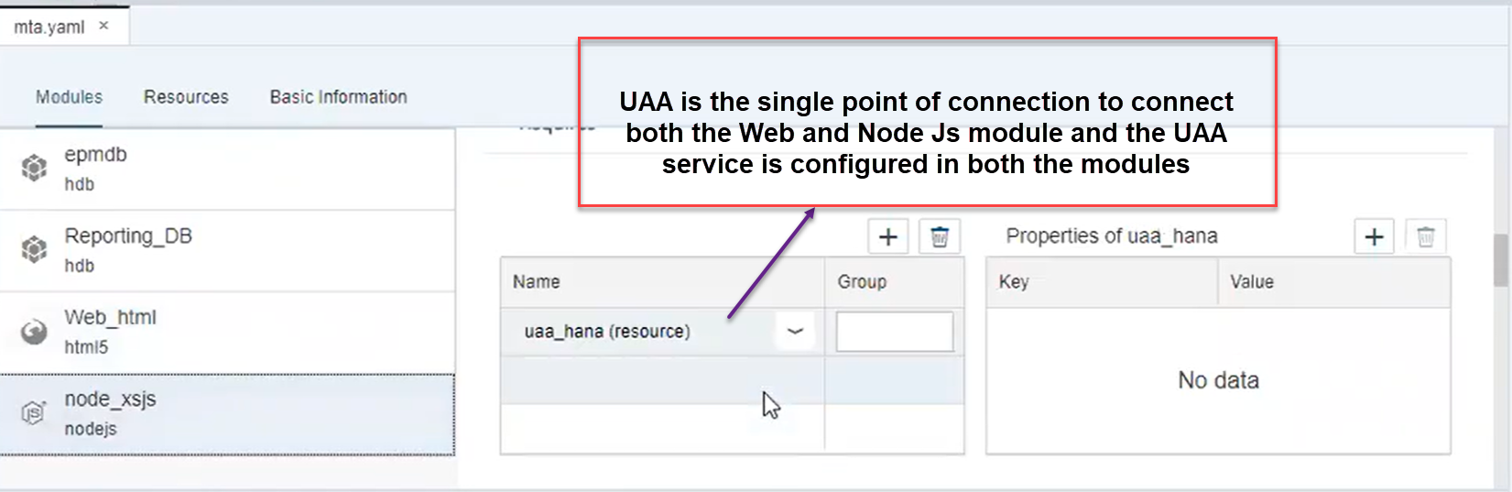

**Accessing the table data through Web module**

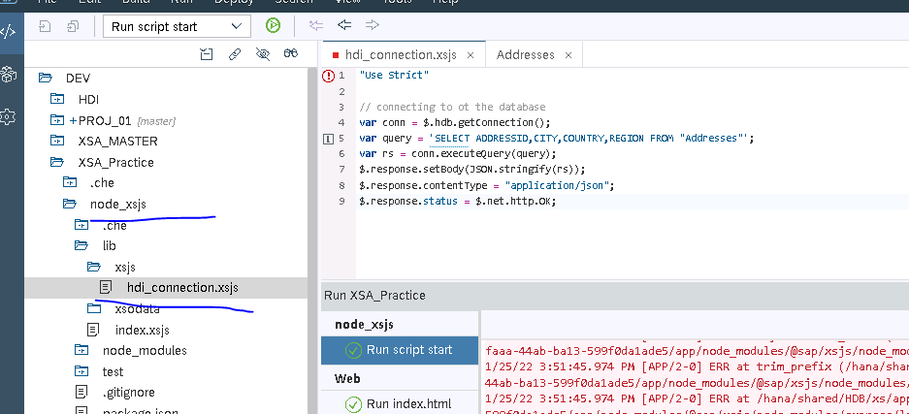

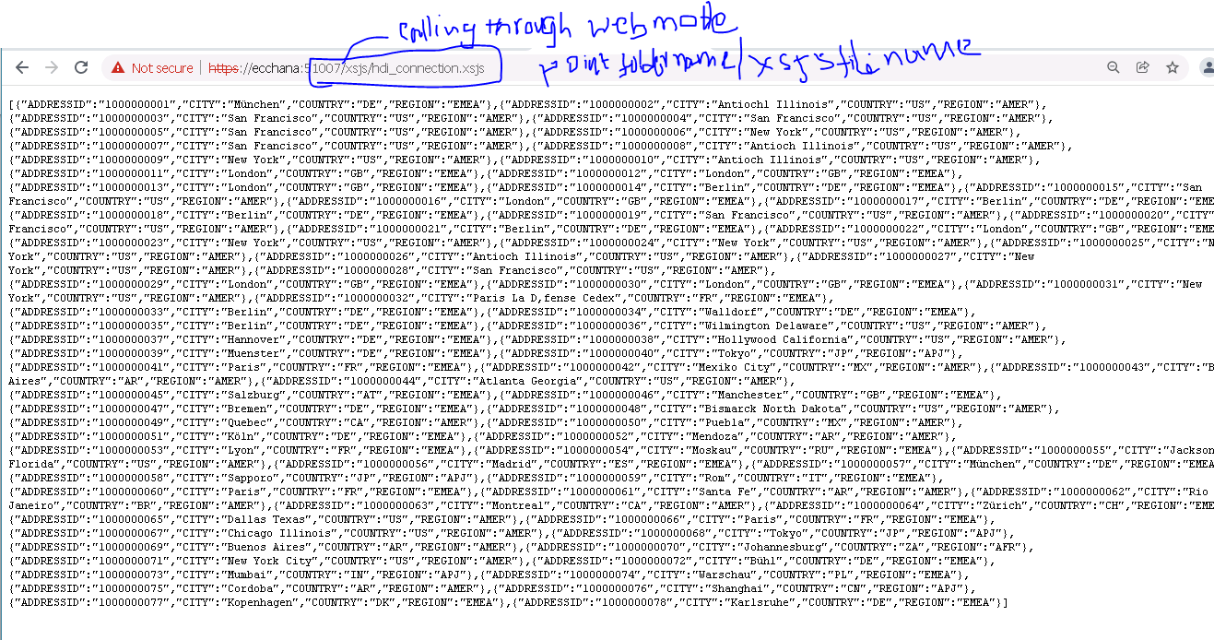

**https://blogs.sap.com/2016/03/28/developing-with-xs-advanced-a-tinyworld-tutorial/**

**PROCEDURE**

PROCEDURE "tinyworld.tinydb::createCountry" (IN im_country NVARCHAR(100),im_continent NVARCHAR(100),

                                            OUT ex_error NVARCHAR(100))

    LANGUAGE SQLSCRIPT SQL

    SECURITY INVOKER AS

    --–READS SQL DATA AS

 BEGIN

  declare noc INETEGER;

    select count(*) into noc from "tinyworld.tinydb::tinyf.world"

    where "continent" = im_continent;

  if :noc = 0 then

   ex_error := 'ERROR: Continent ' || :im_continent || ' does not exist!';

  else

    select count(*) into noc from "tinyworld.tinydb::tinyf.country"

    where "name" = im_country;

   if :noc > 0 then

   ex_error := 'ERROR: Country ' || :im_country || ' already exists!';

    else

       insert into "tinyworld.tinydb::tinyf.country"values (im_country, im_continent);

    end if;

  end if;

  END;

**Calling the Stored Procedure Using the XSJS**

function saveCountry(country) {

var conn = $.hdb.getConnection();

var output = JSON.stringify(country);

var fnCreateCountry = conn.loadProcedure("tinyworld.tinydb::createCountry");

var result = fnCreateCountry({IM_COUNTRY: country.name, IM_CONTINENT: country.partof});

conn.commit();

conn.close();

if (result && result.EX_ERROR != null) { return result.EX_ERROR;}

else {

return output;

    }

}

var country = {

 name: $.request.parameters.get("name"),

  partof: $.request.parameters.get("continent")

};

// validate the inputs here!

var output = saveCountry(country);

$.response.contentType = "application/json";

$.response.setBody(output);

**Scheduling the Jobs in sap HANA Web Ide**

* In the First Step you need confirm in which space you would like have your Job instance, In my case I just select the SAP Space but it’s your chice.

# 

# Go to Service market space and select the Job scheduler and Create a new instance my giving name as Job Scheduler. AS of now it’s not Bind to anyone.

# The Instance is helpful to what a Job scheduler will do.

# 

# Once the Instance is created for the Job Scheduler It will automatically be available in Job scheduler under that particular space (Space where exactly your created the instance)

# 

# Go to the space and select the Job Scheduler by going through the Application

# 

# GO to the Job Scheduler and look the roles assigned currently to the Job Scheduler by going to the Roles

# 

# I will have the Job Scheduler Administrator, Job configuration and Job Views roles by default assigned for that user.

# If the user want the access to the Job scheduler then you can assign that particular user in the members

# 

# Once the user is added to Members you can create the Role by assigning the required Job scheduler roles to the created role then you can assign that role to the user which you have added in the Members to get the access to Job scheduler.

# The Role Collection will have the Role Template and each Role Template again will have multiple roles added to it

# 

# 

# The created role is assigned to the user by going through User management and assign roles

# 

# SAP HANA XS Advanced, Creating an HTML5 Module

Create your first HTML5 module for HTML5 content within your XSA application

#### You will learn

You will learn how to create an HTML5 endpoint with authentication using the User Account and Authorization (UAA) service.

## Prerequisites

* This tutorial is designed for SAP HANA on premise and SAP HANA, express edition. It is not designed for SAP HANA Cloud.
* You have created a Multi-Target Application as explained in this tutorial: [SAP HANA XS Advanced Connect to Web IDE and clone Git Repository](https://developers.sap.com/tutorials/xsa-connecting-webide.html)

# 

# When we are passing the input value at run time with the wrong input selection i.e ValueTw instead of Valuetwo, The output of the browser says the response we wrote in the xsjs i.e “Please correct your input data” also In the Network call node we can see that the Request method is GET and status Code Okay,, Which it shouldn’t to avoid that we writing the response as internal server error

# $.response.status = net.http.INTERNAL_SERVER_ERROR; to get the error as

# 

# 

**4).** Under the Resource section click on add Resource and Provide the necessary details to communicate the Resource and Module section.

* In order to access the Service name which you have created for connecting the classic DB outside of the resource module section, we bind the service name as dynamically by passing it with the ${Service_Name}.

# Node Js

# HDI – HANA Deployment Infrastructure

HDI (HANA Deployment Infrastructure) is a service layer of the SAP HANA database that simplifies the deployment of HANA database artifacts by providing a declarative approach for defining database objects and ensuring a consistent deployment into the database based on a transactional all-or-nothing deployment model and implicit dependency management. It is intended to improve the overall management of database artifacts, particularly in scenarios where its necessary to deploy multiple versions of the same data model into the same database instance.

There are a few high level points about HDI that are important to understand:

* Containers:  All development objects within the scope of HDI now must be within an HDI Container.  The HDI Container allows multiple deployments, sandboxing and enhanced security options for all database artifacts.
* HDI focuses on deployment only:  Unlike the classic HANA Repository, there is no version control or lifecycle management aspects.  These topics are now provided by Git/GitHub.
* Database Objects only: Unlike the classic HANA Repository, HDI only covers pure database development objects. It has nothing to do with JavaScript, XSODATA, or other application-layer artifacts.

# Containers

Container is such an overloaded term in the IT industry.  We have OS containers, runtime containers, application containers, etc. Inside we even already have the concept of MDC – Multi-Database Containers. HDI introduces another thing called a container, but this is lower level than all those other examples.  An HDI container is essentially a database schema. It abstracts the actual physical schema and provides schema-less development and the security isolation that customers have been requesting. Some rules of the HDI Container world:

* All database objects are still deployed into a schema
* This schema is abstracted by the container and is really only designed to be accessed via the container
* All database object definitions and access logic has to be written in a schema-free way
* Only local object access is allowed. This way when the code is branched and points to a different version of the container, the actual physical references can be redirected to a different underlying schema
* Database objects are now owned by a container-specific technical object owner.  There is no longer a single all-powerful technical user (_SYS_REPO). Each technical user only has access to its local container objects.  Any foreign objects must be accessed via Synonym and granted access by the foreign technical user.
* The same container specific technical user is automatically used by XS Advanced when executing database logic. For more details on XSA technical user connectivity see this blog: [SAP HANA SPS 11: New Developer Features; XS Advanced](https://blogs.sap.com/?p=135234)
* No longer are modelded views placed in a single central schema (_SYS_BIC/_SYS_BI). They are now placed in the container specific schema like all other development objects.  This means that some central meta-data concepts must also be duplicated in each container schema.

[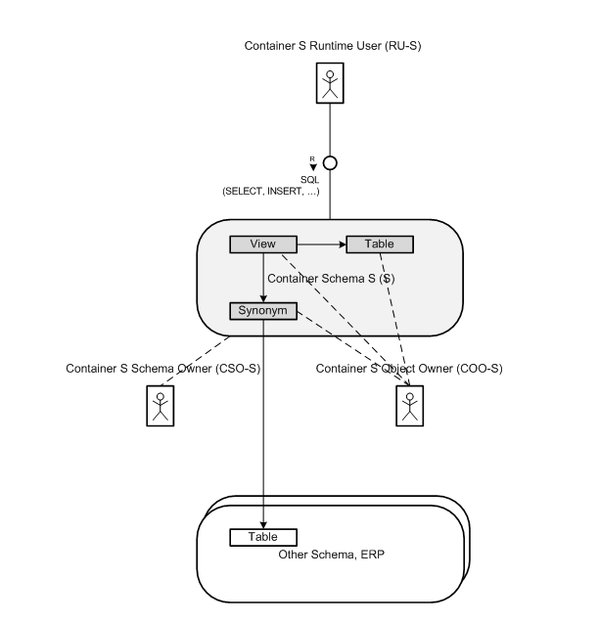](https://blogs.sap.com/wp-content/uploads/2015/12/hdicontainer1_847107.png)

**Figure 1: HDI Containers in Detail**

# Small Example

Probably the best way to explain the new concepts of HDI is to walk through the steps in order to create a simple example. The following example is based upon the initial delivery of SPS 11 and uses the command line tools and external editors. Early next year, SAP will also ship web-based tool that will provide an enhanced development experience.

### Create the Container

HDI commands have both a SQL API and are integrated into XS Advanced. The more common approach is to use HDI in conjunction with XS Advanced and that’s the scenario we will show here. In order to create the container we use the XS command line and create-service command.

[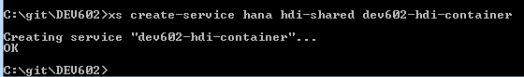](https://blogs.sap.com/wp-content/uploads/2015/12/containercreate_847138.png)

**Figure 2: Create Container**

This one action created the contain both in HANA and exposed it to XS Advanced. Behind the scenes several database schemas and a technical user/owner was also created in the HANA database.  We will see more of what was created later in these steps.

At the root of our XS Advanced application we will need some form of deployment descriptor. The deployment description is contained in the application deployment manifest, which specifies what you want to build (and how) as well as where (and how) to deploy it.  For simple applications you might use the manifest.yml and the corresponding xs push command to send the content to the server.  For more complicated multi-target applications (MTA) with dynamic service port assignment and dependencies you would use the mtad.yaml file.  For more details on deployment descriptors, please see: <http://help.sap.com/hana/SAP_HANA_Developer_Guide_for_SAP_HANA_XS_Advanced_Model_en.pdf>

Regardless of which approach you use, this deployment descriptor is where we would reference the HDI container.  You only need to supply the container name to both the database services and the Node.js or Java services.  This is how any part of our application knows which HANA system to connect to and which schema/technical user to use to connect. We never supply such technical information in our code or design time objects any longer.

The following is an example database service definition section from a manifest.yml.  In the services section we reference the container name we created in the previous step.

[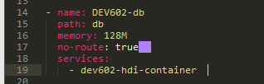](https://blogs.sap.com/wp-content/uploads/2015/12/manifest_db_847171.png)

**Figure 3: manifest.yml database service example**

This is the same definition but as done in the mtad.yaml format:

[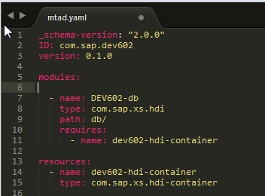](https://blogs.sap.com/wp-content/uploads/2015/12/mtad_db_847181.png)

**Figure 4: mtad.yaml database service example**

### Creating the DB service

For creating/deploying database artifacts we need a database service in our project.  In the above deployment descriptor files we designated that the /db folder in our project would hold this database service.  The database service is really just an SAP supplied node.js module that runs briefly after deployment to call into HANA and ask HDI to deploy the corresponding database artifacts.  It then shuts down. This is why you see the no-route property for this service in the manifest.yml.  This means that no HTTP port will be assigned to this service since it isn’t designed to be interactive.

Inside the db folder we will need a package.json file (since this is a node.js service) and a src folder to hold the actual database artifact definitions. The package.json should declare the dependency to the sap-hdi-deploy module and also call this module as the start up script.  The rest of the content in this example is optional.

[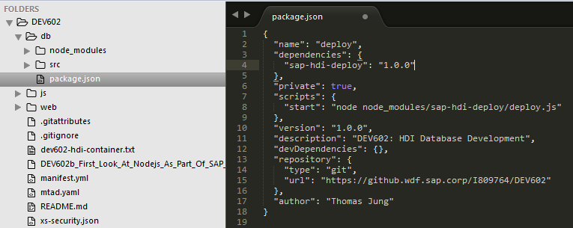](https://blogs.sap.com/wp-content/uploads/2015/12/db_package_json_847183.png)

**Figure 5: Database Service package.json**

Inside the source folder we have two HDI specific configuration files.  In this new world of HDI, there is no SAP HANA Repository and therefore no packages. In the old Repository we used the folders/packages as the namespace for all database objects.  The corresponding functionality in HDI is place a .hdinamespace file in the root of the source and specify the starting namespace for all development objects.  You can then also use the subfolder: append option to attach the folders in your project structure as parts of the namespace as well.

[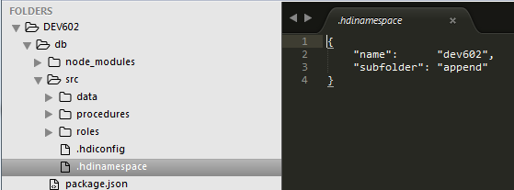](https://blogs.sap.com/wp-content/uploads/2015/12/hdinamespace_847199.png)

**Figure 6: .hdinamespace Example**

The other configuration file is the .hdiconfig.  Here we list the HDI plug-ins and versions for each file extension.  This allows you to control your file extension usage at the project level. More importantly it allows you to target a specific version of the deployment plug-in. In HDI, we use the numbers in the hdiconfig file to do a version check, eg if an application wants plugin x in version 12.1.0 and we only have 11.1.0, then we reject this. So, it’s also more clear that you cannot import an application designed only for SPS 12 into SPS 11. Since the plug-ins are backwards compatible you can use the version 11.1.0 even on your 12.1.0 or later system. This way if your application is designed for to be used on multiple versions you can use the lowest version in the hdiconfig file and explicitly control which versions it is then compatible with.

[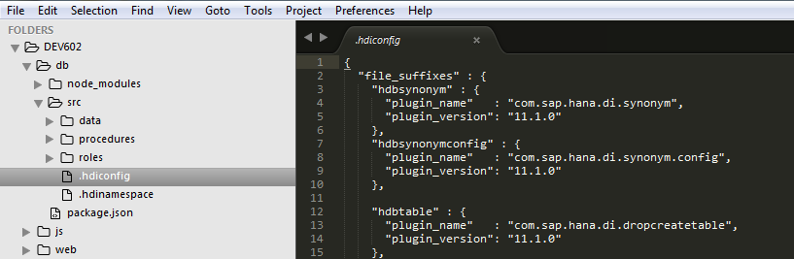](https://blogs.sap.com/wp-content/uploads/2015/12/hdiconfig_847200.png)

**Figure 7: .hdiconfig Example**

### Database Development Objects

The actual database artifact development isn’t all that different from what you do today in the current HANA Repository. Each database object type has its own file and the file extension controls what type of object you want to have. Often you can simply cut and paste the existing objects from the current HANA Repository into your new HDI/XSA project.  For many development artifacts, like stored procedures, you only need to remove the Schema references.

[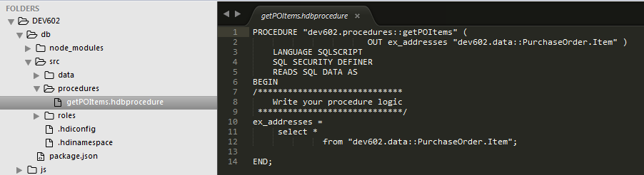](https://blogs.sap.com/wp-content/uploads/2015/12/hdi_procedure_847201.png)

**Figure 8: .hdbprocedure Example in HDI**

Other database artifacts, such as CDS, have new file extensions and updated syntax.  HDBDD is now HDBCDS for example. For the full list of additions and changes to the CDS syntax in HDI, please see this blog: [SAP HANA SPS 11: New Developer Features; HANA Core Data Services](https://blogs.sap.com/?p=135480)

[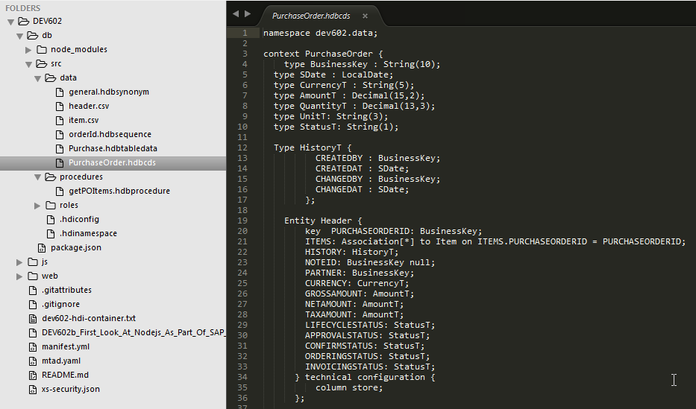](https://blogs.sap.com/wp-content/uploads/2015/12/hdi_hdbcds_847208.png)

**Figure 9: .hdbcds Example in HDI**

Other artifacts have been completely redesigned within HDI.  The hdbti artifact for example has an all new format, options and file extension (hdbtabledata). We have also added a whole new set of DDL-based HDI development artifacts. This means we finally have a way to manage the lifecycle and consistently deploy catalog objects which are also created via pure SQL/DDL.  These artifacts include Tables, Indexes, Constraints, Triggers, Views, Sequences, etc.

Finally its important to reiterate the point that in the HDI world only access to local objects is allowed. There is no such thing as global public synonyms. Therefore common logic such as SELECT FROM DUMMY won’t work any longer.  None of the system tables or views are immediately available. Even for such objects local synonyms must be created and logic within the container can only reference these synonyms.

For example we might create a synonym for DUMMY:

[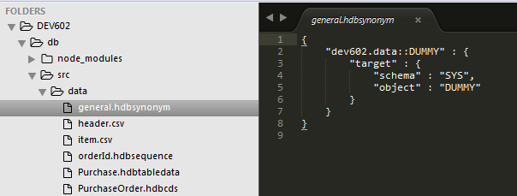](https://blogs.sap.com/wp-content/uploads/2015/12/hdbsynonym_847218.png)

**Figure 10: .hdbsynonym Example in HDI**

Later even for JavaScript or Java code running in XS Advanced we can only use this synonym when querying the database.

var connection = $.hdb.getConnection();

var query = 'SELECT CURRENT_USER FROM "dev602.data::DUMMY"';

var rs = connection.executeQuery(query);

var currentUser = rs[0].CURRENT_USER;

var greeting = 'Hello Application User: ' + $.session.getUsername() +

' Database User: ' + currentUser +

'! Welcome to HANA ';

$.response.contentType = 'text/plain; charset=utf-8';

$.response.setBody(greeting);

### Deployment to the Database

Once we have coded all of our HDI based development artifacts we are ready to deploy the database service to XS Advanced and thereby also deploy the database artifacts into HANA and the underlying schema for the container. For this we will use the **xs push** command. Add on the name of the specific service defined in the manifest.yml file to only deploy the database service for now.

[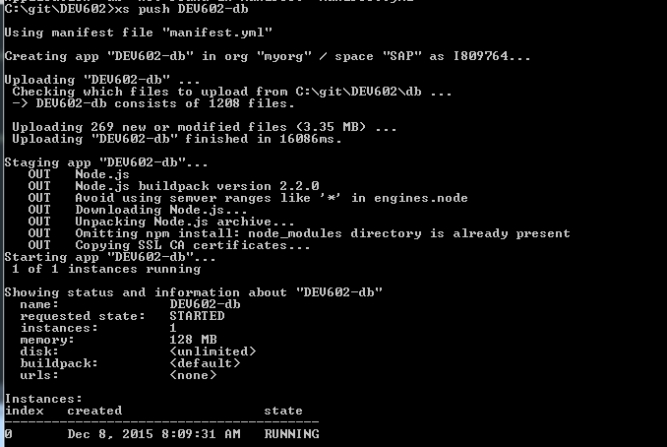](https://blogs.sap.com/wp-content/uploads/2015/12/xs_push_847226.png)

**Figure 11: xs push**

The service should deploy, run, and then very quickly reach completion.  However no actual errors are reported back from the deployment service via the push command. If you had a syntax error in any of the development artifacts, you could only see this if you look at the deployment logs.  The upcoming web-based development tools will streamline this process by displaying the logs immediately in a deployment window. For now, though, we will use the command **xs logs** command to check the status of the HDI deployment.

[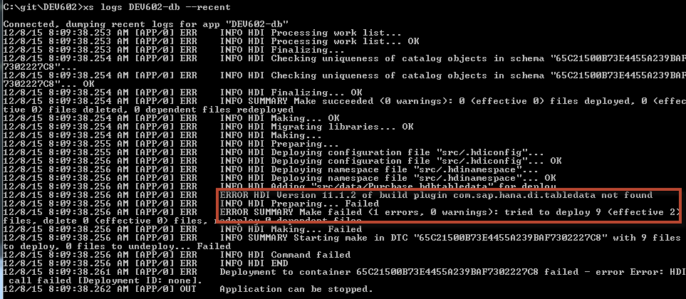](https://blogs.sap.com/wp-content/uploads/2015/12/xs_logs_errors_847228.png)

**Figure 12: xs logs With Errors**

Notice in the above log output we did have an error in the .hdiconfig. I specified an HDI plug-in version that doesn’t exist on my service.  Any sort of syntax or configuration error would show up here in the logs in a similar fashion.

After correcting my error, I can perform the push again. This time everything works correctly and I can see the name of the target schema in the logs. Currently this is the best way to see the correlation between HDI container and the actual physical schema in HANA.

[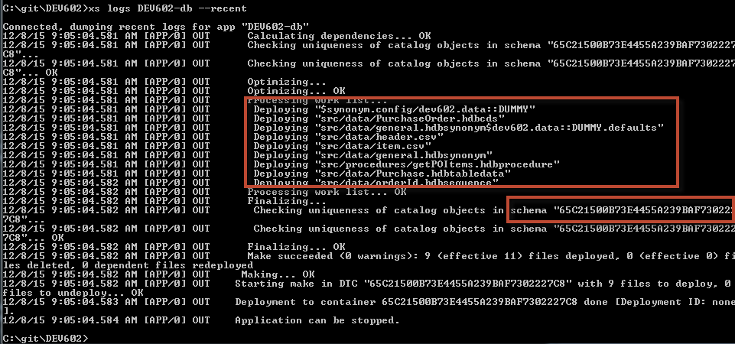](https://blogs.sap.com/wp-content/uploads/2015/12/xs_logs_good_847241.png)

**Figure 12: xs logs With Successful Deployment**

We could now go to the HANA Studio or the Web-based Development Workbench and look at this physical schema. In most SPS 11 and higher systems using HDI there will be many such Schema with long GUID-based names. You likely will have to search for this schema name. You should see several schema were actually created for your container. If your deployment was successful, you should also be able to see the database artifacts you created.

[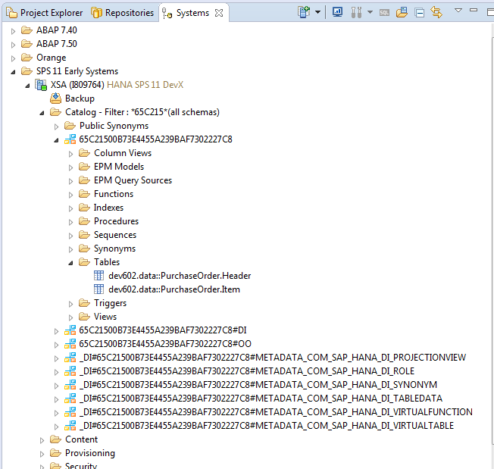](https://blogs.sap.com/wp-content/uploads/2015/12/container_studio_847242.png)

**Figure 13: HDI Container Schema as Viewed from the HANA Studio**

Admittedly the experience of working with the generated schema in the HANA Studio and the Web-based Development Workbench isn’t ideal. This is why early next year with the new SAP Web IDE for SAP HANA, SAP plans to also deliver a new XS Advanced/HDI based catalog tool. This tool will allow you to list and view the details of the HDI containers and avoid the cumbersome lookup of the underlying schema names.

[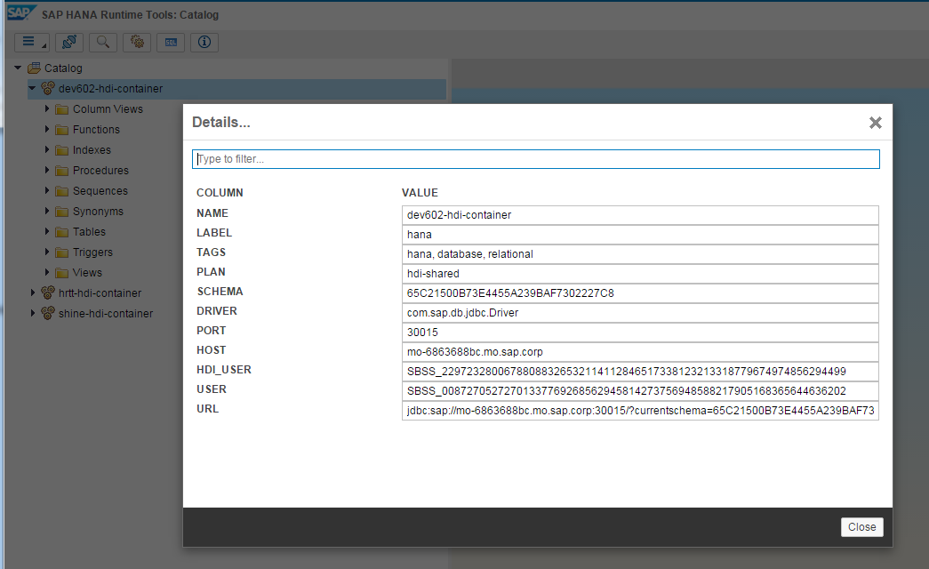](https://blogs.sap.com/wp-content/uploads/2015/12/hdi_catalog1_847243.png)

**Figure 14: HDI/XSA Based Catalog Tool for Viewing HDI Container Details**

This new catalog tool will also allow you to view the data in tables/views and execute procedures within your contain. All access will be done via the technical user of the container. This way developers in development systems can have full access to the development objects they are processing without need for setting up special developer roles for an application.

[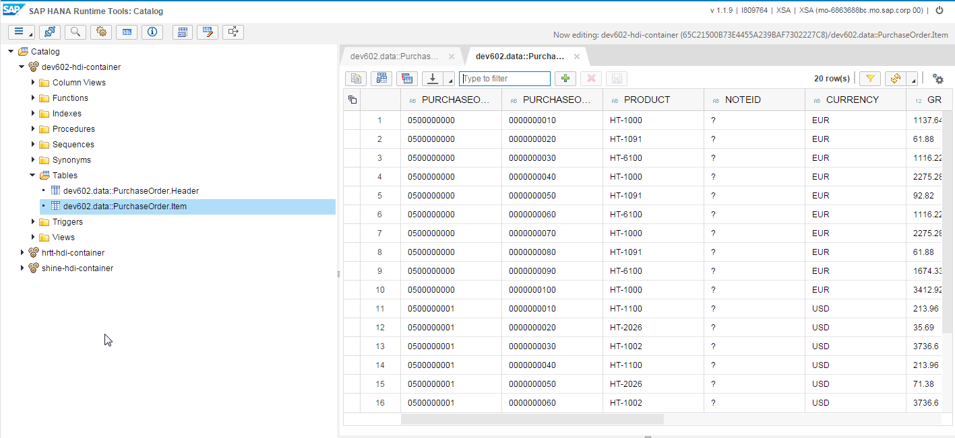](https://blogs.sap.com/wp-content/uploads/2015/12/hdi_catalog2_847253.png)

**Figure 15: HDI/XSA Based Catalog Tool; Data Preview**

# Planning for HDI

With the introduction for HDI there are several logical changes to supported development artifacts as well.  This particularly impacts the area of modeling.  In HDI there is no support for Analytic, Attribute, or Scripted Calculation Views. Therefore you would have the following transition:

* Analytic Views -> Graphical Calculation Views
* Attribute Views -> Graphical Calculation Views
* Scripted Calculation Views -> SQLScript Table Functions
* Column Based Filters -> Filter Expressions
* Derived Parameters by Table -> Only Derived By Procedure (your procedure logic can read a table)

In order to prepare for these changes when moving to HDI, the HANA Studio in SPS 11 contains a migration tool This tool migrate these various view types in place. Meaning it won’t convert them to HDI, but will leave them in the existing HANA Repository. It will convert them to Graphical Calculation Views and/or SQLScript Table Functions in order to prepare for a later move to HDI. This way customers can make the transition in phases for less disruption to their business users.

[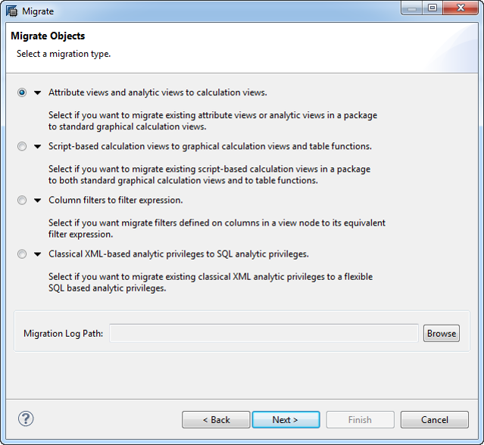](https://blogs.sap.com/wp-content/uploads/2015/12/studio_migrate_847255.png)

# Tutorial: Creating a Modification Exit with SQLScript

Register an SQL script as a modification exit for an OData **create** operation for an entity.

## Prerequisites

To perform this task, you need the following objects:

* A table to expose for the OData create operation, for example, sample.odata::table.hdbtable
* An error type, for example, sample.odata::error.hdbstructure

**Note**These objects are used as **types** in the procedure.

## Context

SAP HANA XS enables you to register custom code that handles the OData write operation for non-trivial cases. In this tutorial, you see how to register a modification exit for an OData CREATE operation for an entity. The procedure you register verifies the data to insert, refuses the insertion request if the specified ID is less than 1000, and in the event of an error, inserts a row with error information into the output table.

## Procedure

1. Create a table definition file using .hdbtable syntax.

The table you create in this step is used in the procedure you create later in the tutorial. The table to expose is defined in sample.odata:table.hdbtable, which should look like the following example:

table.schemaName = "ODATASAMPLES";

table.columns = [{name = "ID"; sqlType = INTEGER; nullable = false;}];

table.primaryKey.pkcolumns = ["ID"];

1. Create a table type for the error output parameter of the exit procedure.

The error type you create in this step is used in the procedure you create later in the tutorial. The error type file sample.odata:error.hdbstructure should look like the following example:

table.schemaName = "ODATASAMPLES";

table.columns = [

{name = "HTTP_STATUS_CODE"; sqlType = INTEGER;},

{name = "ERROR_MESSAGE"; sqlType = NVARCHAR; length = 100;},

{name = "DETAIL"; sqlType = NVARCHAR; length = 100;}

];

1. Create a procedure that runs before the UPDATE event.

The table and error type objects you created in the previous steps are used as **types** in the procedure created here. The procedure also performs a verification on the data, rejects the insertion in case of an ID below 1000, and inserts a row with error information into the output table.

The procedure sample.odata:createmethod.hdbprocedure should look like the following example:

procedure "ODATA_TEST"."sample.odata::createmethod"

(IN new "sample.odata::table", OUT error "sample.odata::error")

language sqlscript

sql security invoker as

id INT;

begin

select ID into id from :new;

if :id < 1000 then

error = select 400 as http_status_code,

'invalid ID' error_message,

'value must be >= 1000' detail from dummy;

else

insert into "sample.odata::table" values (:id);

end if;

end;

1. Register the procedure to be executed at the CREATE event.

You use the create using keywords to register the procedure, as illustrated in the following OData service file:

service {

“sample.odata::table”

create using “sample.odata::createmethod”;

}

# [In SAP HANA how can I generate a range of numbers, eg from 1 to 10?](https://stackoverflow.com/questions/24051074/in-sap-hana-how-can-i-generate-a-range-of-numbers-eg-from-1-to-10)

CREATE PROCEDURE "DEMO_PROC"(

IN ID INTEGER )

LANGUAGE SQLSCRIPT AS

/*********BEGIN PROCEDURE SCRIPT ************/

BEGIN

DECLARE

I INTEGER;

DROP TABLE TEST_TABLE;

CREATE COLUMN TABLE "TEST_TABLE" (ID INTEGER, NAME VARCHAR(10));

FOR i IN 1..: ID DO

If(MOD(:I,2)

INSERT INTO "TEST_TABLE" VALUES (:i);

COLUMN TABLE "BusinessPartner"(

"PARTNERID" NVARCHAR(10) NOT NULL,

"PHONENUMBER" NVARCHAR(15),

"ADDRESSID" NVARCHAR(10),

"COMPANYNAME" NVARCHAR(100),

PRIMARY KEY (

"PARTNERID"

)

Importing data

{

"format_version": 1,

"imports": [

{

"target_table": "BusinessPartner",

"source_data": {

"data_type": "CSV",

"file_name": "businessPartner.csv",

"has_header": true

},

"import_settings": {

"import_columns": [

"PARTNERID",

"ADDRESSID",

"COMPANYNAME"

]

}

}

]

}

PARTNERID,PHONENUMBER,ADDRESSID,COMPANYNAME

100000000,622734567,1000000034,SAP

100000001,3088530,1000000035,Becker Berlin

100000002,3023352668,1000000036,DelBont Industries

100000003,511403266,1000000037,Talpa

100000004,2244668800,1000000038,Panorama Studios

100000005,2511415,1000000039,TECUM

100000006,9078563412,1000000040,Asia High tech

100000007,149744423,1000000041,Laurent

100000008,7257716,1000000042,AVANTEL

100000009,1133557799,1000000043,Telecomunicaciones Star

100000010,6789012345,1000000044,Pear Computing Services

100000011,6623612804,1000000045,Alpine Systems

100000012,2589436180,1000000046,New Line Design

100000013,4507867136,1000000047,HEPA Tec

100000014,5850428367,1000000048,Anav Ideon

100000015,7609448173,1000000049,Robert Brown Entertainment

100000016,6879342945,1000000050,Mexican Oil Trading Company

100000017,2208791738,1000000051,Meliva

100000018,4440238917,1000000052,Compostela

100000019,6328490087,1000000053,Pateu

100000020,4050378468,1000000054,Russian Electronic Trading Company

100000021,6065470312,1000000055,Florida Holiday Company

100000022,7980023486,1000000056,Quimica Madrilenos

100000023,3629731486,1000000057,Getränkegroßhandel Janssen

100000024,3206580974,1000000058,JaTeCo

100000025,4580963184,1000000059,Tessile Casa Di Roma

100000026,1012697341,1000000060,Vente Et Réparation de Ordinateur

100000027,7345697824,1000000061,Developement Para O Governo

100000028,469614115,1000000062,Brazil Technologies

COLUMN TABLE "BusinessPartner"(

    "PARTNERID" NVARCHAR(10) NOT NULL,

    "PHONENUMBER" NVARCHAR(15),

    "ADDRESSID" NVARCHAR(10),

    "COMPANYNAME" NVARCHAR(100),

    PRIMARY KEY (

        "PARTNERID"

    )

) UNLOAD PRIORITY 5 AUTO MERGE;

Access Scenarios

Blog on explaining the 4 scenarios.

https://blogs.sap.com/2019/08/02/xs-advanced-db-access-scenarios-overview/

for scenario 1, to get S4 HANA data simulation, we can import SFLIGHT data into HANA system

Below blog expalins the files to be imported and steps for the same.

https://blogs.sap.com/2018/12/18/howto-import-sflight-sample-data-into-sap-hana-from-a-local-computer/

----

--Scenario 4:

set schema "ANALYTICS#DI";

create local temporary column table "#PRIVILEGES" like "_SYS_DI"."TT_SCHEMA_PRIVILEGES";

insert into "#PRIVILEGES" ("PRIVILEGE_NAME", "PRINCIPAL_SCHEMA_NAME", "PRINCIPAL_NAME") values ('SELECT', '', 'MYUSER');

insert into "#PRIVILEGES" ("PRIVILEGE_NAME", "PRINCIPAL_SCHEMA_NAME", "PRINCIPAL_NAME") values ('INSERT', '', 'MYUSER');

insert into "#PRIVILEGES" ("PRIVILEGE_NAME", "PRINCIPAL_SCHEMA_NAME", "PRINCIPAL_NAME") values ('UPDATE', '', 'MYUSER');

insert into "#PRIVILEGES" ("PRIVILEGE_NAME", "PRINCIPAL_SCHEMA_NAME", "PRINCIPAL_NAME") values ('DELETE', '', 'MYUSER');

call "ANALYTICS#DI"."GRANT_CONTAINER_SCHEMA_PRIVILEGES"("#PRIVILEGES", "_SYS_DI"."T_NO_PARAMETERS", ?, ?, ?);

--call "ANALYTICS#DI"."REVOKE_CONTAINER_SCHEMA_PRIVILEGES"("#PRIVILEGES", "_SYS_DI"."T_NO_PARAMETERS", ?, ?, ?);

drop table "#PRIVILEGES";

----

set schema "ANALYTICS#DI";

create local temporary column table "#ROLES" like "_SYS_DI"."TT_SCHEMA_ROLES";

insert into "#ROLES" ("ROLE_NAME", "PRINCIPAL_SCHEMA_NAME", "PRINCIPAL_NAME") values ('container_role', '', 'MYUSER');

call "ANALYTIS#DI"."GRANT_CONTAINER_SCHEMA_ROLES"("#ROLES", "_SYS_DI"."T_NO_PARAMETERS", ?, ?, ?);

--call "ANALYTICS#DI"."REVOKE_CONTAINER_SCHEMA_ROLES"("#ROLES", "_SYS_DI"."T_NO_PARAMETERS", ?, ?, ?);

drop table "#ROLES";